# Warning

Increasing speed of the laptop CPU can overheat the laptop, so, without a good cooler below laptop it will simply shut down because of overheat… I am suggesting you buying at least:

<https://www.coolermaster.com/en-global/products/notepal-i300/?tab=tech_spec>

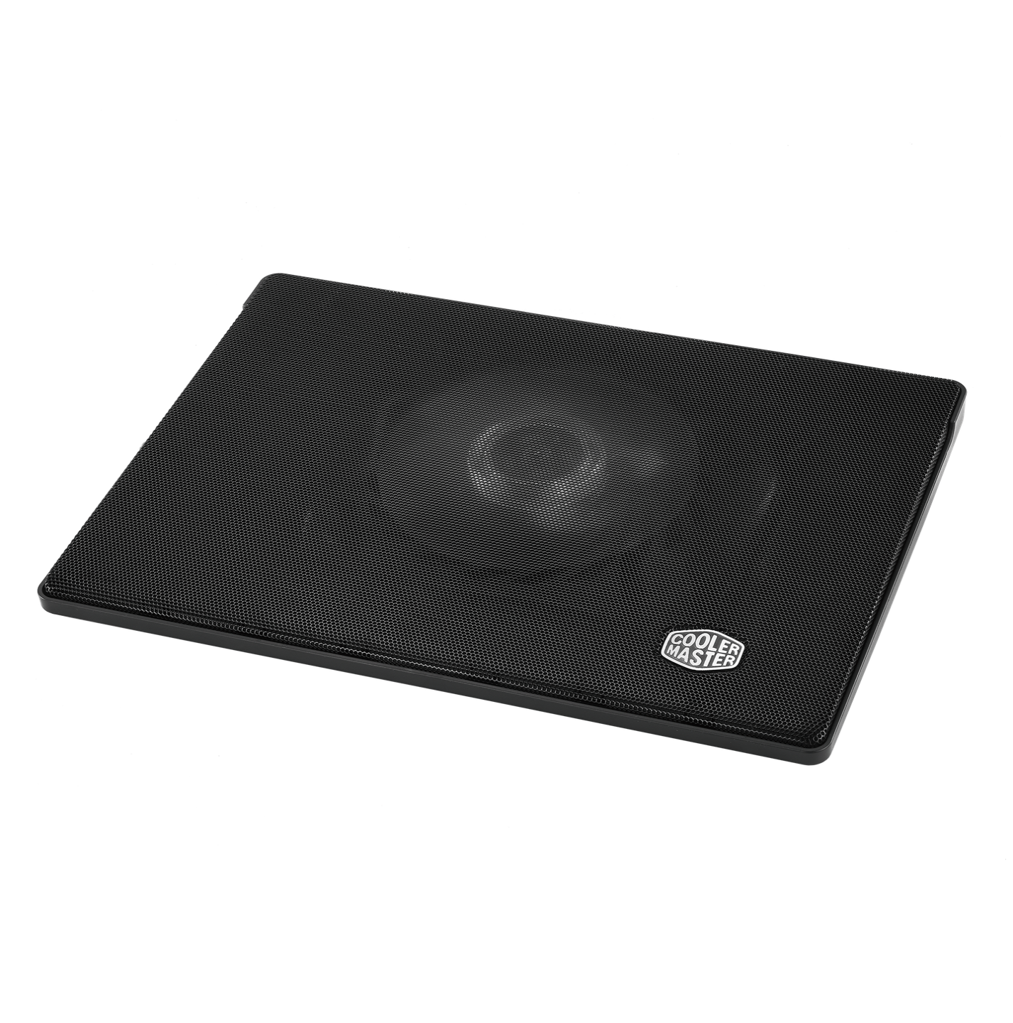

Specifications:

* Fan Dimensions (L x W x H)160 x 160 x 15 mm / 6.3 x 6.3 x 0.6 inch
* Fan Speed 700–1400 RPM ± 150
* Fan Airflow 35 - 70 CFM

Laptop temperatures with this cooler always connected and working are:

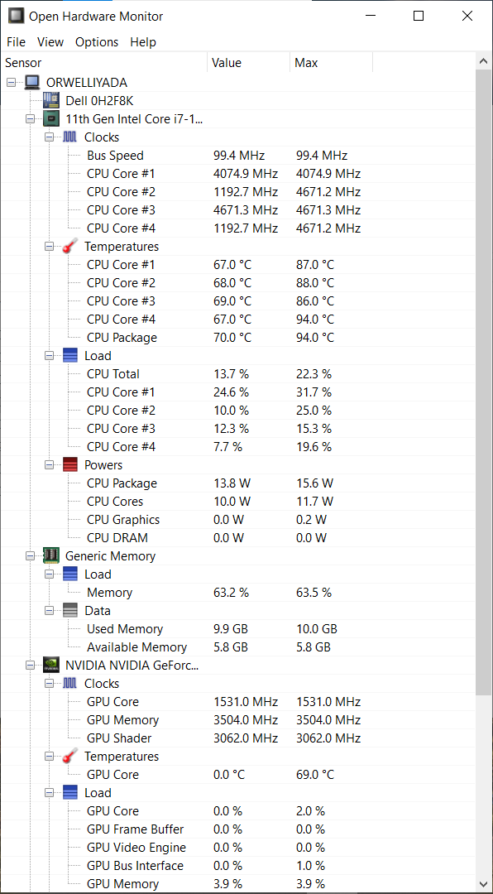

# How to speed up your Intel processor using Registry Keys

In my example I have a laptop “Dell Vostro 5502” with processor “11th Gen Intel® Core™ i7-1165G7 @ 2.80GHz” working on up to 4.7 GHz where it is for some reason set to work on up to 1.69 GHz with a possible boost up to 2.7 GHz and later on 4.1 GHz (because for some reason Windows doesn’t allow the full usage of the CPU)…

In Task Manager you will find this description about the processor:

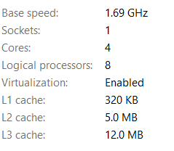

First thing that I was asking is the 2 given options in the Registry Keys for “EfficiencyClass” when I can have 3 if processor is locked on 1.69… The other thing to consider here is enabled energy saver locking that processor on 1.69 GHz, and not on 2.7 GHz… That energy saver with Windows given options shall make this Intel CPU to work on 0.87 GHz and even slower on about 0.4 GHz when the greater CPU consumption and usage comes in place…

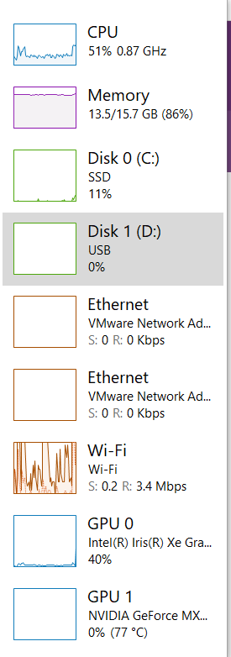

First of all to avoid that we need to fix some Registry values and settings:

* “Computer\HKEY_LOCAL_MACHINE\SYSTEM\ControlSet001\Control\Power”

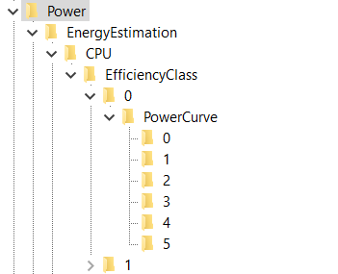

Here I would pay attention what does EnergyEstimationEnabled option… Leave it turned on, because, by some thinking – under the folder EnergyEstimation , but that is my choice…

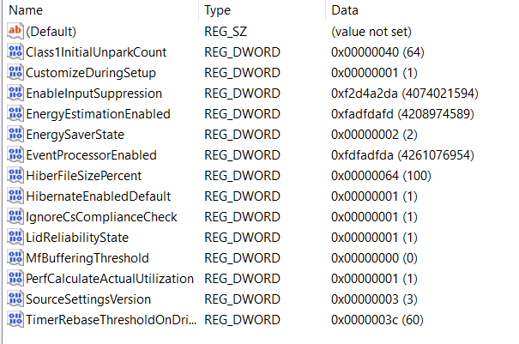

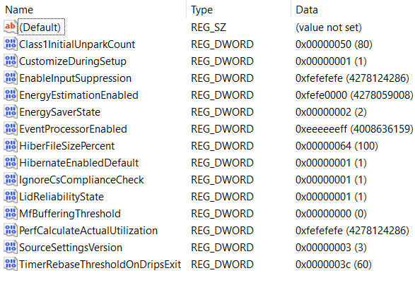

## EfficiencyClasses

* Computer\HKEY_LOCAL_MACHINE\SYSTEM\ControlSet001\Control\Power\EnergyEstimation\CPU\EfficiencyClass\0

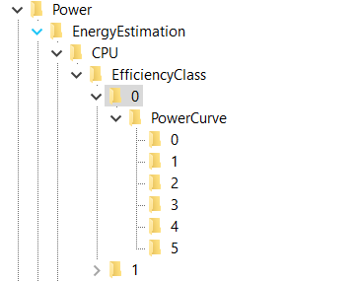

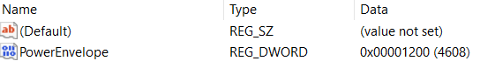

* Computer\HKEY_LOCAL_MACHINE\SYSTEM\ControlSet001\Control\Power\EnergyEstimation\CPU\EfficiencyClass\0\PowerCurve\0

Explanation for the values: FrequencyPercent is represented in decimals as a percentage, and PowerEnvelope is represented in HexaDecimal values but through the Decimal values – so for example if you type in the Decimal value “1000” you should see it as is written in HexaDecimal values, which translated gives us 4.096 GHz… You should notice one interesting thing that you can’t type in all of the Frequencies for the processor because in hexadecimal values you can write and letters A – F, so for example “A99” would be 2.713 GHz, and here you can write only numbers which means either you would need to agree to processor speed of (in Hexadecimal values) “999” or “1000”, which is translated: 2.457 GHz (for “999”) or 4.096 GHz (for “1000)…

So my setting is:

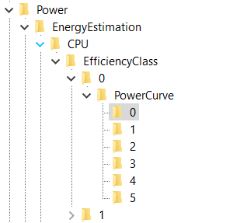

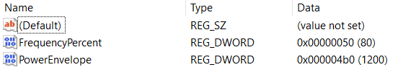

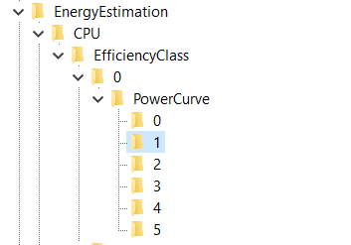

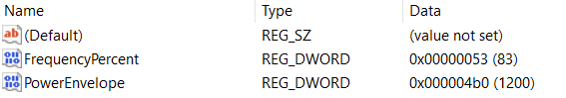

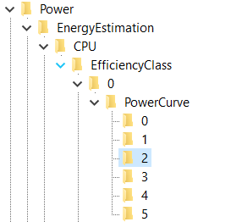

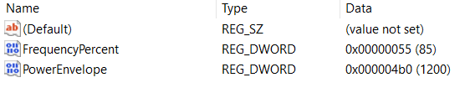

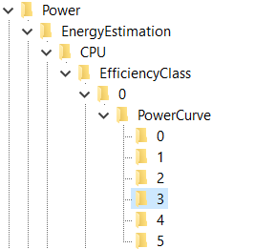

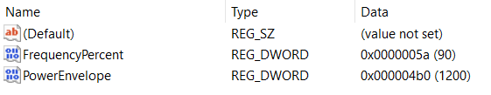

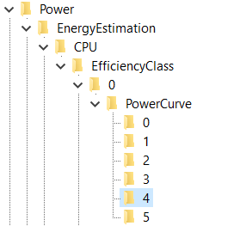

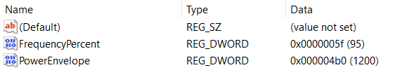

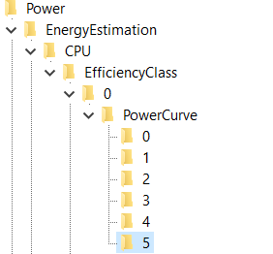

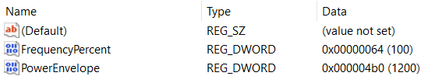

* Computer\HKEY_LOCAL_MACHINE\SYSTEM\ControlSet001\Control\Power\EnergyEstimation\CPU\EfficiencyClass\1

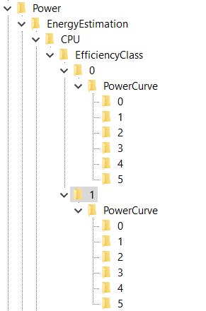

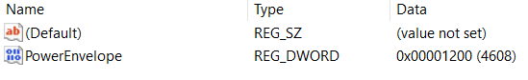

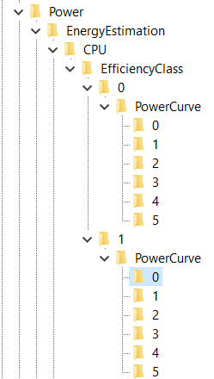

One solution I created for myself – I have retyped all values from the EfficiencyClass “0” into “1”…

Other unnecessary solution is something like this:

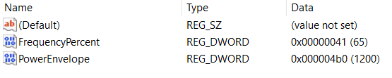

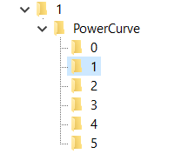

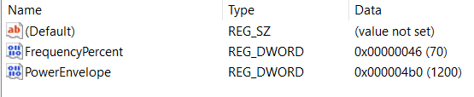

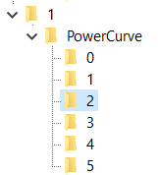

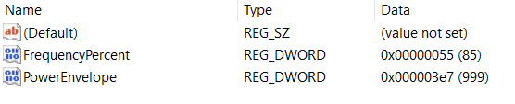

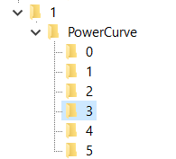

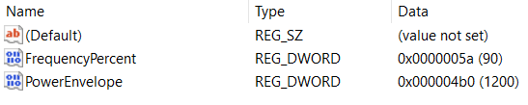

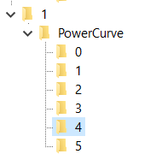

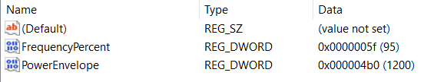

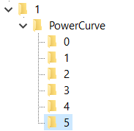

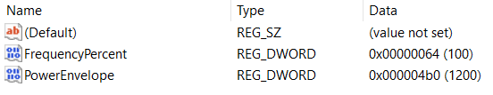

## Residual energy

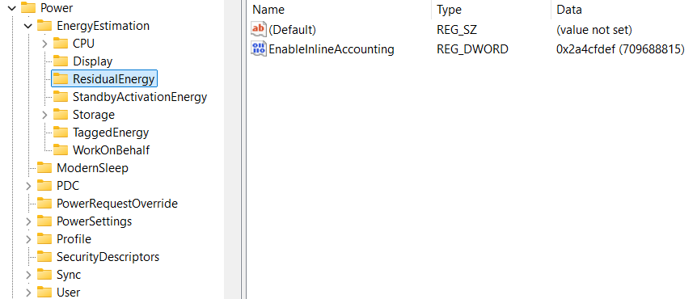

## WorkOnBehalf

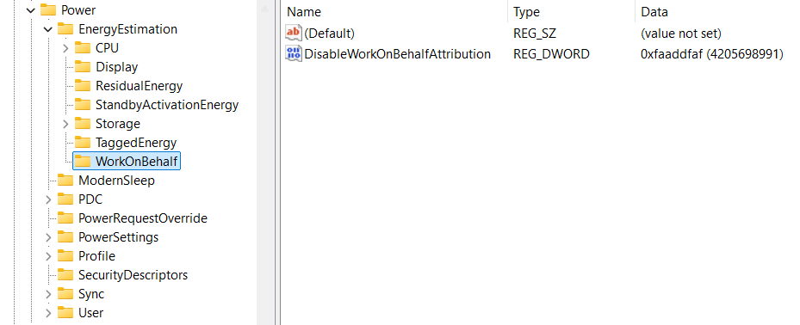

## VetoPolicies

* “Computer\HKEY_LOCAL_MACHINE\SYSTEM\ControlSet001\Control\Power\PDC”

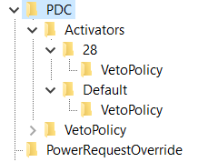

Laptop works faster if VetoPolicy options are turned off…

* Computer\HKEY_LOCAL_MACHINE\SYSTEM\ControlSet001\Control\Power\PDC\Activators\28\VetoPolicy
  + EA:PowerStateDischarging: ffff ffff
* Computer\HKEY_LOCAL_MACHINE\SYSTEM\ControlSet001\Control\Power\PDC\Activators\Default\VetoPolicy
  + EA:EnergySaverEngaged: ffff ffff

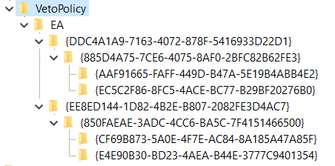

I am not sure if these values represent the maximum speed of the processor but I have placed them all on maximum for my processor:

* Computer\HKEY_LOCAL_MACHINE\SYSTEM\ControlSet001\Control\Power\PDC\VetoPolicy\EA\{DDC4A1A9-7163-4072-878F-5416933D22D1}\{885D4A75-7CE6-4075-8AF0-2BFC82B62FE3}\{AAF91665-FAFF-449D-B47A-5E19B4ABB4E2}
  + Type 4121 -> 4700
* Computer\HKEY_LOCAL_MACHINE\SYSTEM\ControlSet001\Control\Power\PDC\VetoPolicy\EA\{DDC4A1A9-7163-4072-878F-5416933D22D1}\{885D4A75-7CE6-4075-8AF0-2BFC82B62FE3}\{EC5C2F86-8FC5-4ACE-BC77-B29BF20276B0}
  + Type 4106 -> 4700
* Computer\HKEY_LOCAL_MACHINE\SYSTEM\ControlSet001\Control\Power\PDC\VetoPolicy\EA\{EE8ED144-1D82-4B2E-B807-2082FE3D4AC7}\{850FAEAE-3ADC-4CC6-BA5C-7F4151466500}\{CF69B873-5A0E-4F7E-AC84-8A185A47A85F}
  + Type 4106 -> 4700
* Computer\HKEY_LOCAL_MACHINE\SYSTEM\ControlSet001\Control\Power\PDC\VetoPolicy\EA\{EE8ED144-1D82-4B2E-B807-2082FE3D4AC7}\{850FAEAE-3ADC-4CC6-BA5C-7F4151466500}\{E4E90B30-BD23-4AEA-B44E-3777C9401354}
  + Type 4145 -> 4700

You will notice that those folders – “keys” there is a value that has a DWORD named “Value” and that it is turned off, I have placed it to 0…

## PowerSettings

* “Computer\HKEY_LOCAL_MACHINE\SYSTEM\ControlSet001\Control\Power\PowerSettings”

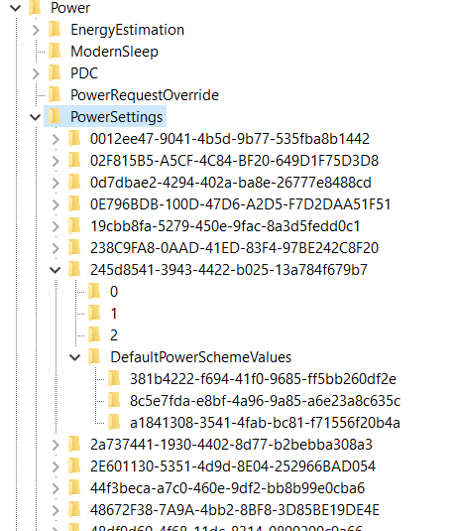

Talking about PowerSettings you need to turn High Performance on, set graphics to work in High performance mode, to set CPU to work by High Performance if you wish on all 3 levels (3 different keys under “DefaultPowerSchemeValues” folder) – because it is unknown in Registry Editor which level is for “Best Battery Life” setting, which is “Balanced” setting, and which is for “Best (High) performance” setting… What I can conclude, for my processor and type of Windows that I have – key: “8c5e7fda-e8bf-4a96-9a85-a6e23a8c635c” represents the “High performance” mode and mostly from that key I have been copying to other two keys it’s own already set values… Some keys I have changed completely, adjusting values how I liked…

How this part of the registry works? First you will have a “key” (folder) where you will find options that you can implement under “keys” (folders) 0, 1, 2 and you will have a folder where you can implement those options named: “DefaultPowerSchemeValues”… In those folders you can find the description and a “friendly name” (also a type of a description) of the current part of the Registry Keys… Each of the main folders named for example: “0”, “1” or “2” will have some type of a value that you can use later on… That value you will find under a DWORD (data) name “SettingValue”… The best setting whether it’s under folder “0”, “1” or “2” you can copy into the “AcSettingIndex” or “DcSettingIndex”, or “ProvAcSettingIndex” or “ProvDcSettingIndex”…

In cases where you don’t have options under keys (folders) “0”, “1”, “2”, you will have some type of a scale that you can implement… Maximum value of the scale you can find under the main folder and it’s DWORD named “ValueMax” and it’s possible minimum under a DWORD named “ValueMin”… Always take a look at: DWORD named ValueUnits that will have a description for example: “@%SystemRoot%\system32\powrprof.dll,-81,percent” – there the last word we can find is the word “percent” meaning you should implement in decimal numbers value from 0 to 100 representing some kind of a percentage of a usage for some of the situations…

Some of the settings that I have implemented are:

* Computer\HKEY_LOCAL_MACHINE\SYSTEM\ControlSet001\Control\Power\PowerSettings\54533251-82be-4824-96c1-47b60b740d00

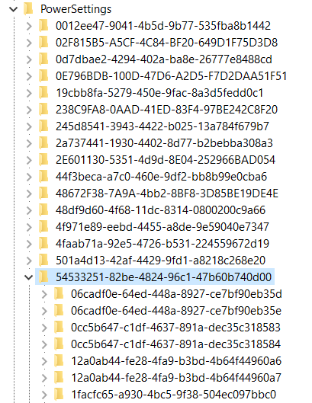

Under power settings you will find the key: “54533251-82be-4824-96c1-47b60b740d00” with “Processor power settings” and you need to see each of the keys (folders) it has and to adjust them except time settings which I haven’t changed…

### Processor performance increase threshold

* “Computer\HKEY_LOCAL_MACHINE\SYSTEM\ControlSet001\Control\Power\PowerSettings\54533251-82be-4824-96c1-47b60b740d00\06cadf0e-64ed-448a-8927-ce7bf90eb35d”
* Value different 30, 60, 90

### Processor performance increase threshold for Processor Power Efficiency Class 1

* Computer\HKEY_LOCAL_MACHINE\SYSTEM\ControlSet001\Control\Power\PowerSettings\54533251-82be-4824-96c1-47b60b740d00\06cadf0e-64ed-448a-8927-ce7bf90eb35e
* 60 – 90

### Specify the minimum number of unparked cores/packages allowed

* Computer\HKEY_LOCAL_MACHINE\SYSTEM\ControlSet001\Control\Power\PowerSettings\54533251-82be-4824-96c1-47b60b740d00\0cc5b647-c1df-4637-891a-dec35c318583
  + Description: Specify the minimum number of unparked cores/packages allowed (in percentage).
  + Setting implemented: 64 (100)

### Specify the minimum number of unparked cores/packages allowed

* Computer\HKEY_LOCAL_MACHINE\SYSTEM\ControlSet001\Control\Power\PowerSettings\54533251-82be-4824-96c1-47b60b740d00\1facfc65-a930-4bc5-9f38-504ec097bbc0
  + Description: Specify the minimum number of unparked cores/packages allowed (in percentage).
  + Setting implemented: 64 (100) – 10

### Processor performance core parking min cores for Processor Power Efficiency Class 1

* “Computer\HKEY_LOCAL_MACHINE\SYSTEM\ControlSet001\Control\Power\PowerSettings\54533251-82be-4824-96c1-47b60b740d00\0cc5b647-c1df-4637-891a-dec35c318584”
* 0

### Processor performance decrease threshold

* Specify the lower busy threshold that must be met before decreasing the processor's performance state (in percentage).
* “Computer\HKEY_LOCAL_MACHINE\SYSTEM\ControlSet001\Control\Power\PowerSettings\54533251-82be-4824-96c1-47b60b740d00\12a0ab44-fe28-4fa9-b3bd-4b64f44960a6”
* 20 – 10 – 60 – 10

### Processor performance decrease threshold for Processor Power Efficiency Class 1

* Computer\HKEY_LOCAL_MACHINE\SYSTEM\ControlSet001\Control\Power\PowerSettings\54533251-82be-4824-96c1-47b60b740d00\12a0ab44-fe28-4fa9-b3bd-4b64f44960a7
* 20 – 30

### Hybrid containment zone important utility percentage

* “Computer\HKEY_LOCAL_MACHINE\SYSTEM\ControlSet001\Control\Power\PowerSettings\54533251-82be-4824-96c1-47b60b740d00\12fd031f-53d2-4bf4-ac6d-c699fc9538c7”
* Specify the important utility percentage that once met, allow workload to move to no containment zone
* 0

### Processor Restriction Count

* “Computer\HKEY_LOCAL_MACHINE\SYSTEM\ControlSet001\Control\Power\PowerSettings\54533251-82be-4824-96c1-47b60b740d00\1a98ad09-af22-42ca-8e61-f0a5802c270a”
* Specify the restriction processor count for this QoS of threads.
* 0

### Initial performance for Processor Power Efficiency Class 1 when unparked

* “Computer\HKEY_LOCAL_MACHINE\SYSTEM\ControlSet001\Control\Power\PowerSettings\54533251-82be-4824-96c1-47b60b740d00\1facfc65-a930-4bc5-9f38-504ec097bbc0”
* 32 (50)

### Processor performance core parking concurrency threshold

* “Computer\HKEY_LOCAL_MACHINE\SYSTEM\ControlSet001\Control\Power\PowerSettings\54533251-82be-4824-96c1-47b60b740d00\2430ab6f-a520-44a2-9601-f7f23b5134b1”
* 61 (97), 61, 5f

### Processor performance core parking increase time

* “Computer\HKEY_LOCAL_MACHINE\SYSTEM\ControlSet001\Control\Power\PowerSettings\54533251-82be-4824-96c1-47b60b740d00\2ddd5a84-5a71-437e-912a-db0b8c788732”
* In time check intervals
* Same as before: 3, 7, 1

### Processor energy performance preference policy

* “Computer\HKEY_LOCAL_MACHINE\SYSTEM\ControlSet001\Control\Power\PowerSettings\54533251-82be-4824-96c1-47b60b740d00\36687f9e-e3a5-4dbf-b1dc-15eb381c6863”
* (33), (50) / 0, 0 / (70) / (60) / (25), (33)

### Processor energy performance preference policy for Processor Power Efficiency Class 1

* “Computer\HKEY_LOCAL_MACHINE\SYSTEM\ControlSet001\Control\Power\PowerSettings\54533251-82be-4824-96c1-47b60b740d00\36687f9e-e3a5-4dbf-b1dc-15eb381c6864\DefaultPowerSchemeValues\381b4222-f694-41f0-9685-ff5bb260df2e”
* (33), (50) / (0), (0) / (60), (60)

### Processor energy performance preference policy for Processor Power Efficiency Class 2

* “Computer\HKEY_LOCAL_MACHINE\SYSTEM\ControlSet001\Control\Power\PowerSettings\54533251-82be-4824-96c1-47b60b740d00\36687f9e-e3a5-4dbf-b1dc-15eb381c6864”
* (33), (50), (60)

### Allow Throttle States

* Computer\HKEY_LOCAL_MACHINE\SYSTEM\ControlSet001\Control\Power\PowerSettings\54533251-82be-4824-96c1-47b60b740d00\3b04d4fd-1cc7-4f23-ab1c-d1337819c4bb
  + FriendlyName: Allow Throttle States
* Setting implemented: 0 – Off

### Processor performance increase time for Processor Power Efficiency Class 1

* “Computer\HKEY_LOCAL_MACHINE\SYSTEM\ControlSet001\Control\Power\PowerSettings\54533251-82be-4824-96c1-47b60b740d00\4009efa7-e72d-4cba-9edf-91084ea8cbc3”
* 1

### Processor performance decrease policy

* Computer\HKEY_LOCAL_MACHINE\SYSTEM\ControlSet001\Control\Power\PowerSettings\54533251-82be-4824-96c1-47b60b740d00\40fbefc7-2e9d-4d25-a185-0cfd8574bac6
  + FriendlyName: Processor performance decrease policy
* Setting implemented: Single
* Computer\HKEY_LOCAL_MACHINE\SYSTEM\ControlSet001\Control\Power\PowerSettings\54533251-82be-4824-96c1-47b60b740d00\40fbefc7-2e9d-4d25-a185-0cfd8574bac7
  + FriendlyName: Processor performance decrease policy for Processor Power Efficiency Class 1
* Setting implemented: Single
* Computer\HKEY_LOCAL_MACHINE\SYSTEM\ControlSet001\Control\Power\PowerSettings\54533251-82be-4824-96c1-47b60b740d00\447235c7-6a8d-4cc0-8e24-9eaf70b96e2b
  + Processor performance core parking parked performance state
* Best option for the speed of processor: Lightest Performance State
* My setting implemented: No preference
* Some theory on that topic: Unused CPUs enter parked state and not to spend energy they can enter Deepest Performance state to save power and reduce the heat… Otherwise faster option is “Lightest Performance state”…
* Computer\HKEY_LOCAL_MACHINE\SYSTEM\ControlSet001\Control\Power\PowerSettings\54533251-82be-4824-96c1-47b60b740d00\45bcc044-d885-43e2-8605-ee0ec6e96b59
  + FriendlyName: Processor performance boost policy
  + All Settings implemented: 0x64 (or Decimal: 100 (%))
* Computer\HKEY_LOCAL_MACHINE\SYSTEM\ControlSet001\Control\Power\PowerSettings\54533251-82be-4824-96c1-47b60b740d00\465e1f50-b610-473a-ab58-00d1077dc418
  + FriendlyName: Processor performance increase policy
  + Setting implemented: Rocket
* Computer\HKEY_LOCAL_MACHINE\SYSTEM\ControlSet001\Control\Power\PowerSettings\54533251-82be-4824-96c1-47b60b740d00\4e4450b3-6179-4e91-b8f1-5bb9938f81a1
  + FriendlyName: Processor duty cycling
  + Setting implemented: Allow processor duty cycling.
* Computer\HKEY_LOCAL_MACHINE\SYSTEM\ControlSet001\Control\Power\PowerSettings\54533251-82be-4824-96c1-47b60b740d00\5d76a2ca-e8c0-402f-a133-2158492d58ad
  + Description: Specify if idle states should be disabled.
  + Setting implemented: Enable idle
* Computer\HKEY_LOCAL_MACHINE\SYSTEM\ControlSet001\Control\Power\PowerSettings\54533251-82be-4824-96c1-47b60b740d00\6c2993b0-8f48-481f-bcc6-00dd2742aa06
  + FriendlyName: Processor idle threshold scaling
  + Setting implemented: Disable scaling
* Computer\HKEY_LOCAL_MACHINE\SYSTEM\ControlSet001\Control\Power\PowerSettings\54533251-82be-4824-96c1-47b60b740d00\71021b41-c749-4d21-be74-a00f335d582b
  + Description: Specify the number of cores/packages to park when fewer cores are required.
  + Setting implemented: Ideal number of cores
* Computer\HKEY_LOCAL_MACHINE\SYSTEM\ControlSet001\Control\Power\PowerSettings\54533251-82be-4824-96c1-47b60b740d00\75b0ae3f-bce0-45a7-8c89-c9611c25e100
  + FriendlyName: Maximum processor frequency
  + Setting implemented: Decimal value: 4700
* Computer\HKEY_LOCAL_MACHINE\SYSTEM\ControlSet001\Control\Power\PowerSettings\54533251-82be-4824-96c1-47b60b740d00\75b0ae3f-bce0-45a7-8c89-c9611c25e101
  + FriendlyName: Maximum processor frequency for Processor Power Efficiency Class 1
  + Setting implemented: Decimal value: 2457
* Computer\HKEY_LOCAL_MACHINE\SYSTEM\ControlSet001\Control\Power\PowerSettings\54533251-82be-4824-96c1-47b60b740d00\7f2f5cfa-f10c-4823-b5e1-e93ae85f46b5
  + FriendlyName: Heterogeneous policy in effect.
  + Setting implemented: Use heterogeneous policy 0

Don’t forget to check options for Graphic card:

* Computer\HKEY_LOCAL_MACHINE\SYSTEM\ControlSet001\Control\Power\PowerSettings\5FB4938D-1EE8-4b0f-9A3C-5036B0AB995C
  + FriendlyName: GPU preference policy
  + Setting implemented: No preference (because other setting I had was: Low Power)

Check Energy Saving settings:

* Computer\HKEY_LOCAL_MACHINE\SYSTEM\ControlSet001\Control\Power\PowerSettings\DE830923-A562-41AF-A086-E3A2C6BAD2DA
* Computer\HKEY_LOCAL_MACHINE\SYSTEM\ControlSet001\Control\Power\PowerSettings\DE830923-A562-41AF-A086-E3A2C6BAD2DA\5C5BB349-AD29-4ee2-9D0B-2B25270F7A81
  + FriendlyName: Energy Saver Policy
  + Setting implemented: User

Also, you can go back to processor settings and find the “Processor performance increase threshold” and “Processor performance decrease threshold” options, as I know I have changed some of the percentages, for example from 35 to 20 if is faster and from 45 to 50, but maybe I have pushed it above the edge or below the edge (I am not even sure)… Maybe those settings are fine by themselves…

My options there are in decimal values:

* Computer\HKEY_LOCAL_MACHINE\SYSTEM\ControlSet001\Control\Power\PowerSettings\54533251-82be-4824-96c1-47b60b740d00\7b224883-b3cc-4d79-819f-8374152cbe7c
  + FriendlyName: Processor idle promote threshold
  + Setting implemented: 14 (20)
* Computer\HKEY_LOCAL_MACHINE\SYSTEM\ControlSet001\Control\Power\PowerSettings\54533251-82be-4824-96c1-47b60b740d00\943c8cb6-6f93-4227-ad87-e9a3feec08d1
  + FriendlyName: Processor performance core parking over utilization threshold
  + Setting implemented: 1e (30)
* Computer\HKEY_LOCAL_MACHINE\SYSTEM\ControlSet001\Control\Power\PowerSettings\54533251-82be-4824-96c1-47b60b740d00\06cadf0e-64ed-448a-8927-ce7bf90eb35d
  + FriendlyName: Processor performance increase threshold
* Setting implemented: 0 (0)
* Computer\HKEY_LOCAL_MACHINE\SYSTEM\ControlSet001\Control\Power\PowerSettings\54533251-82be-4824-96c1-47b60b740d00\06cadf0e-64ed-448a-8927-ce7bf90eb35e
  + FriendlyName: Processor performance increase threshold for Processor Power Efficiency Class 1
* Setting implemented: 0 (0)
* Computer\HKEY_LOCAL_MACHINE\SYSTEM\ControlSet001\Control\Power\PowerSettings\54533251-82be-4824-96c1-47b60b740d00\12a0ab44-fe28-4fa9-b3bd-4b64f44960a6
  + FriendlyName: Processor performance decrease threshold
  + Description: Specify the lower busy threshold that must be met before decreasing the processor's performance state (in percentage).
* Setting implemented: 64 (100)
* Computer\HKEY_LOCAL_MACHINE\SYSTEM\ControlSet001\Control\Power\PowerSettings\54533251-82be-4824-96c1-47b60b740d00\12a0ab44-fe28-4fa9-b3bd-4b64f44960a7
  + FriendlyName: Processor performance decrease threshold
  + Description: Specify the lower busy threshold that must be met before decreasing the processor's performance state (in percentage).
* Setting implemented: 64 (100)

There is also a setting for “Processor performance boost mode”:

* Computer\HKEY_LOCAL_MACHINE\SYSTEM\ControlSet001\Control\Power\PowerSettings\54533251-82be-4824-96c1-47b60b740d00\be337238-0d82-4146-a960-4f3749d470c7
* Setting implemented: 5

Set System cooling policy:

* Computer\HKEY_LOCAL_MACHINE\SYSTEM\ControlSet001\Control\Power\PowerSettings\54533251-82be-4824-96c1-47b60b740d00\94D3A615-A899-4AC5-AE2B-E4D8F634367F\1
  + Setting implemented: Increase fan speed before slowing the processor

Edit the option for Minimal Power Management:

* Computer\HKEY_CURRENT_USER\Control Panel\PowerCfg

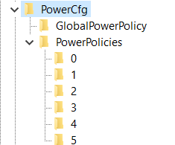

Here, on my Windows, under a number 4 is:

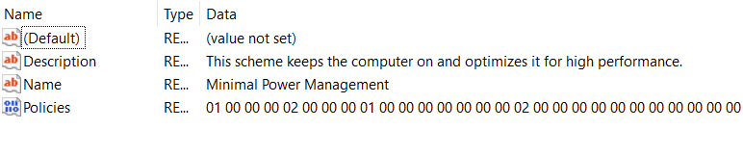

So just set in the PowerCfg string CurrentPowerPolicy: 4

# Graphic cards

This Laptop “Dell Vostro 5502” has also dual graphics cards - integrated “Intel® Iris® Xe Graphics” and “NVIDIA GeForce MX330”… It has 16GB of RAM memory, and 500 GB SSD hard drive…

There is a topic of a small and reducing processor speed thanks to the small “Bus” (an implemented cable for transferring the data in between the graphic card and the other chips), and that because of it (maybe set on 1.3 GHz) and the processor reduces it’s speed…

## HardwareAcceleration

In Registry Editor add the keys into:

* “Computer\HKEY_CURRENT_USER\SOFTWARE\Microsoft\Avalon.Graphics”

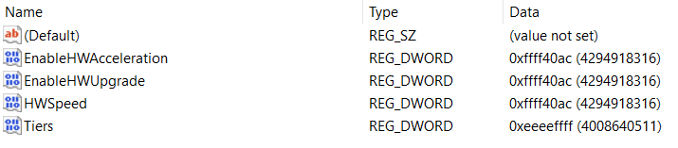

### Old settings that made no point:

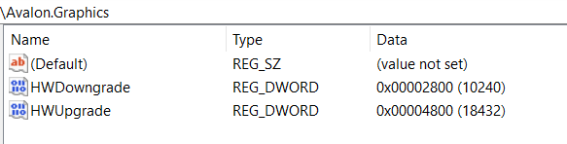

I believe that the next solution makes no point:

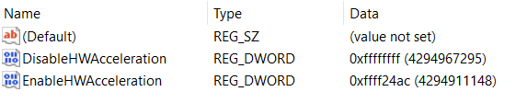

* I created REG_DWORD named DisableHWAcceleration and set it to the value: ffffffff or f22afdfd
* I created REG_DWORD named EnableHWAcceleration and set it to the value: ffff24ac, maybe wrong answers are: ffff2a4c, cbed2a4c, fadefa9c – but those codes we can use if we find the setting on our chips complex which we can find the association when we look at the title: Avalon.Graphics
* Maybe 2a4cd2da – last “a” is there maximum of 2GHz…
* Maybe 4a7cd4df – last “f” is there because of as much as it can of 4GHz…

## DirectX

* “Computer\HKEY_LOCAL_MACHINE\SOFTWARE\Microsoft\DirectX”

Edit “MaxFeatureLevel”, “MinFeatureLevels”, “D3D12MinFeatureLevel” and “D3D12MaxFeatureLevel”

* MaxFeatureLevel: “c100”
  + MaxFeatureLevel possible options are:
    - C100
    - c256
    - F256
    - Fadcb
    - “Fadbcdef”
    - “fadbcfdf”
* D3D12MinFeatureLevel: c100
  + Possible options are:
    - 0 (to see retardedness)
    - c100
    - F (to see regular even if it isn’t)
    - 15, 20, 25, 30, 35, …, 100
    - f10
    - f11, f12, f13, f14, f15
    - f100, f110, f120, f130, f140, f150
    - f1000

Edit those values and through the inside of the “DirectX” key keys:

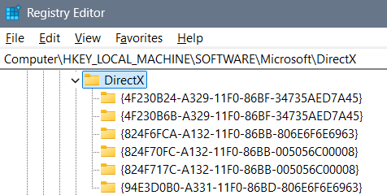

### Old settings and unnecessary images:

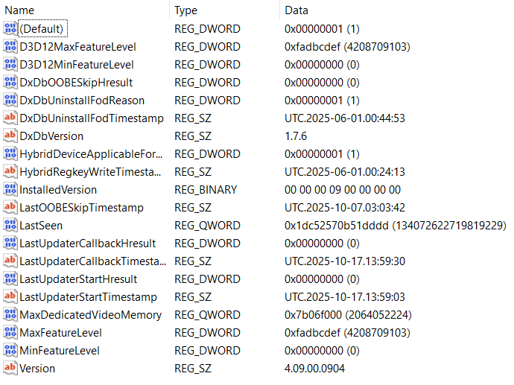

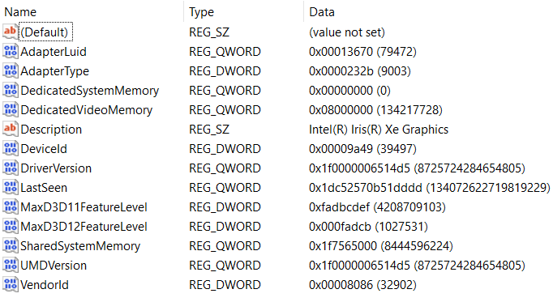

## Intel Graphics Software

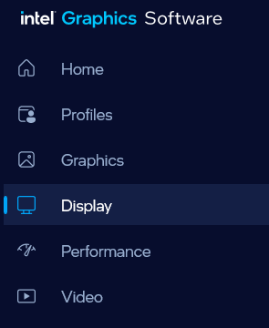

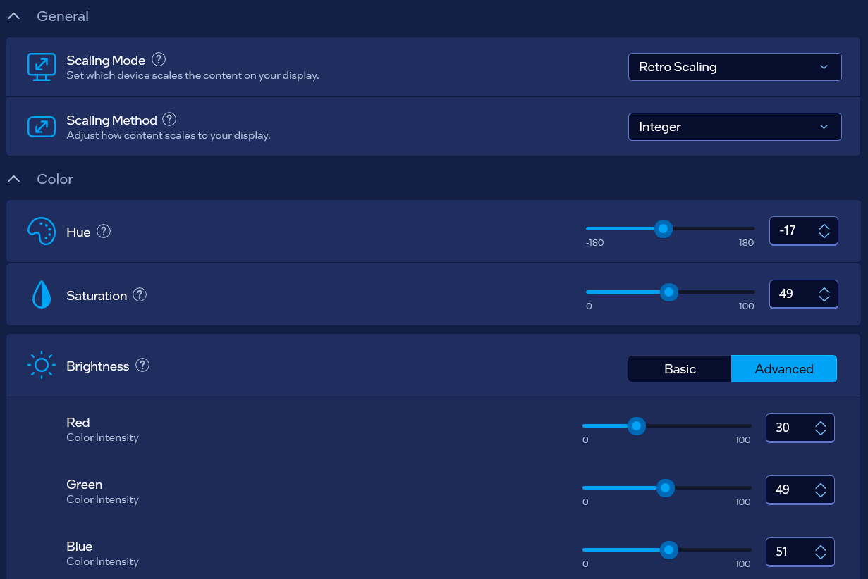

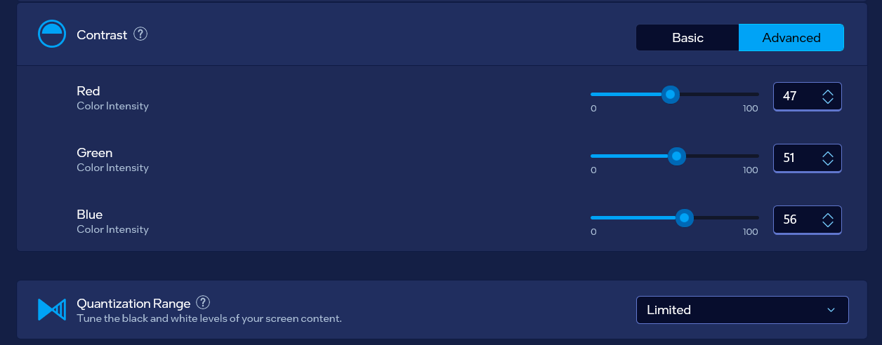

## “GraphicDrivers” Key

Go to: “Computer\HKEY_LOCAL_MACHINE\SYSTEM\ControlSet001\Control\GraphicsDrivers”

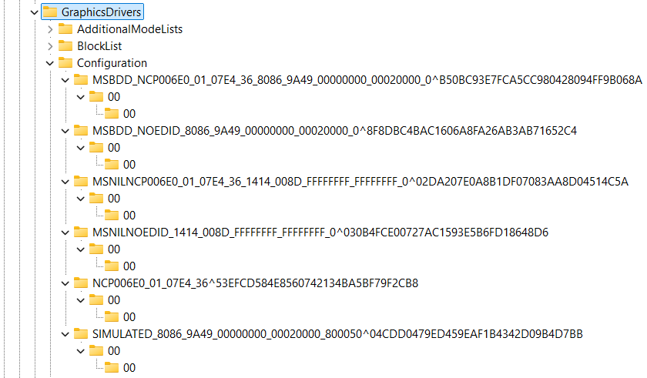

You should change in all of the “Configuration” keys files named “00”, and eventually main ones where you find PixelRate, PixelFormat and ColorBasis…

* PixelFormat best setting is “acfedbce”, other settings are:
  + “fe17”
  + “fe27”
  + “acfedbce”
  + “fedcbdef”
* ColorBasis best setting is “fedbcadf”, other settings are:
  + “3”
  + “fe17”
  + “fedbcadf”
  + For the whole and overall American system suggested value is: “fadbacdf”, but that system is belonging to primitive beings as humans are, and one day after a change it won’t be fitting anymore…
* PixelRate best setting is “fefedefe”, other settings are:
  + “fffffffe”
  + “ffffffff”
  + “69c3320”
  + “84157a0”
  + “19275801”
  + “97216543”
  + “fadcbdaf”
  + “fedbcedf”
  + “fedcbde”, by the belief correct value
  + “ffdcebd”
  + “ffedcebd”
  + “dceadbf”
  + “dafafafa”
  + “fefedefe”, 8 numbers value that represents the correctness of work
  + “fffedfed”, how display shouldn’t be working
  + “fedbacdf”, how it shouldn’t be working
  + “fffedcbe”, how it shouldn’t be working for 3D

## inetcpl.cpl

* Press Win+R to open “Run” program and then type: “inetcpl.cpl” and press enter
* Go to advanced

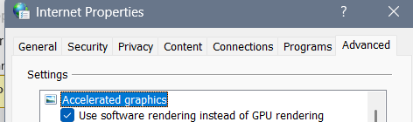

## Intel graphics settings:

### Intel folder list: “Computer\HKEY_LOCAL_MACHINE\SOFTWARE\Intel”

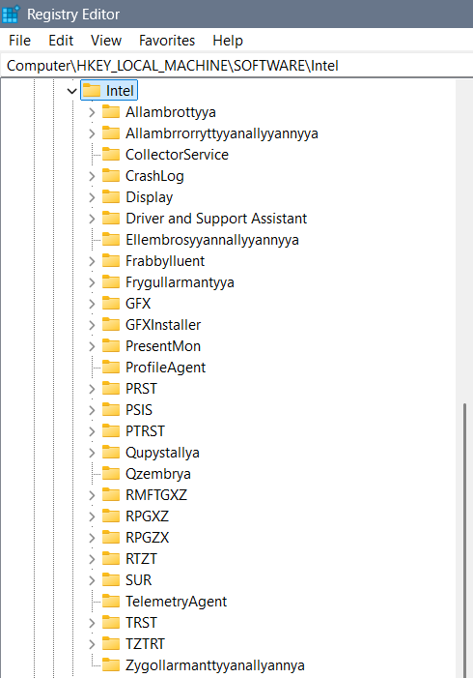

Part 1:

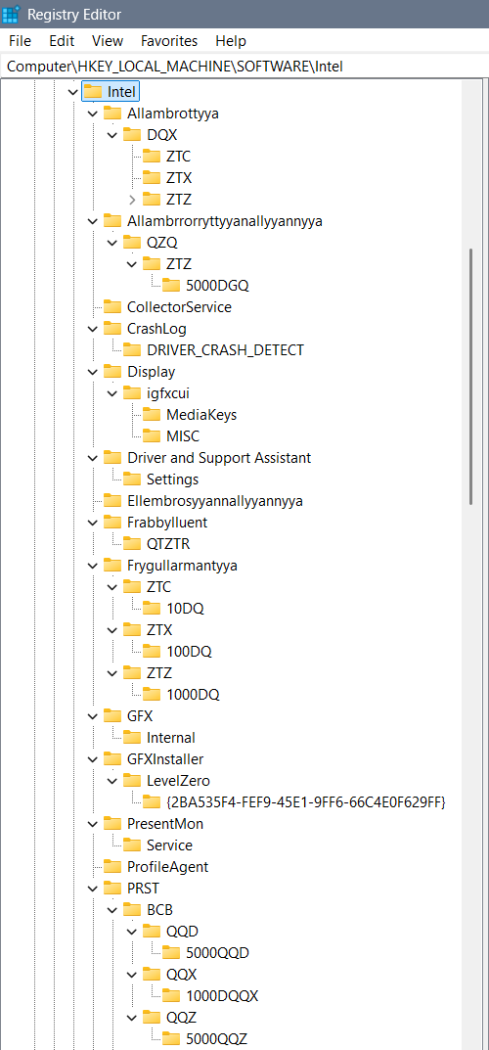

Part 2:

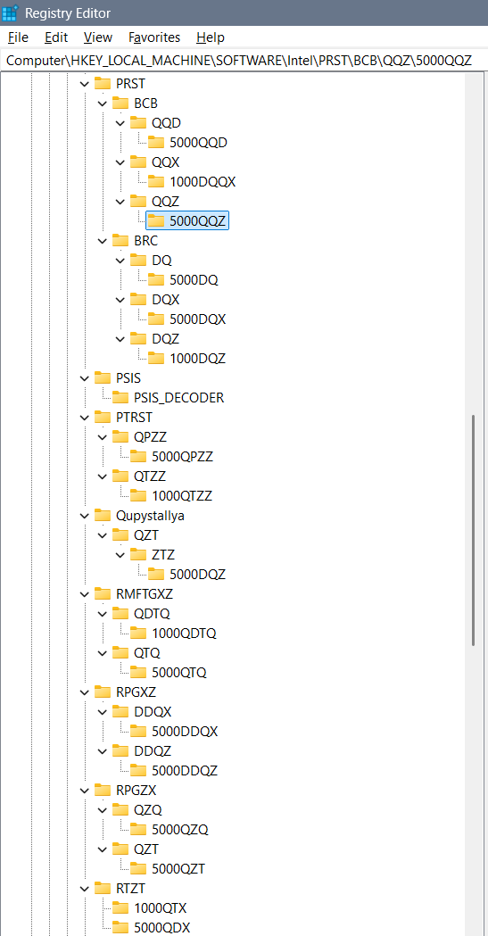

Part 3:

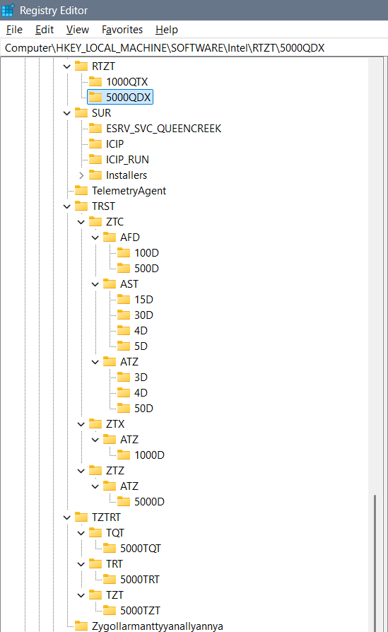

### Folders:

Each of the definitions of “watches”, “XD” (multiple D, as in 3D) environments, and etc. we define through the folders as are:

* Allambrottyya – we use for the purpose of the “knowledge watch” defined as QX or complex DQX…
* Allambrrorryttyyanallyyannyya – for the purpose of measuring one towards another as is QDQ or through time we use QXQ, or through complex idea for both we can use QZQ
* Ellembrosyyannallyyannyya – would be some kind of enablement of the predefined keys – for example of 3DLUT
* Frygullarmantyya – can have keys (folders) as are AMFTXZ for the purpose now moment, DMFTXZ for the purpose of future and XMFTXZ for the past… The “watch” we are using is complexed Q or simple Q (for now), QQ (for past), and QQQ and (for future)… So implementing it in XD stage is DQ watch…
* PRST – or longer “Perrserrwattory” is a folder is for emotions and feelings we are dividing into the BCB for emotions and BRC for emotions and feelings… The watch we are using in BCB is QQX, and a watch we are using in BRC is DQX…
  + Quzzembrya (for simpler beings Quzembrya), Wallzembrya, Dezzembrya, and Allzembrrya represent the idea of QQX or QQZ watches and they could belong to complexed written PRST – or Perrserrwattoryum… And I find it unnecessary for it to be main folder… Simply the explanation is that some emotions, feelings and levels of intelligence we divide in 113D, 114D or 115D and that is simply their description…
* PTRST – QPZZ & QTZZ – what when we ain’t using a watch… There is always a command for that and we can use 2 types of codes – when watches ain’t working (because we didn’t write them – then we can use data through different types of watches), or when they don’t need to work (but for example we need them – also for example because we didn’t wrote them)… QPZZ represents Qupyzzallya and QTZZ represents Quzzalltallyannyzzallya
* Qupystallya – represents self responsive system towards the aliens used in open system for smart beings… In that folder we can use complex watch for past, now moment and future – maybe it’s DQZ or QZT…
* Qzembrya – represents a system for responsiveness – collecting the data from the aliens from which we need to know something
* RPGZX – “Reprogryggerryzyxyannallyannya” (shorter “Reprogryggerry”) we are using for alien communication – QXQ for reading the aliens, and QZT for collecting data about them
* RPGXZ – Repprogrezzyxstya or longer “Repprogrezzyxstallyannallyannya” has the idea of exchanging and shortcutting the values of time measurements with an idea that some years pass with a different idea and so that we can still measure them… For that option we use the DDQX clock…
* RPGZX – we find simple time passing but for a need of a long enough time needed to pass… And that time simply in some cases can’t be measured so we will extrapolate the “Q” option for a time and get it unlimited “QQQQQQQ…”… To shorten that we will use the: “QZQ” option, and “QZT” when we are still able to calculate the values…
* RTZT – What when we didn’t write the watch for the 3D options because we simply didn’t think of it, or when we don’t fit into any of the watches for some strange reason? We can use the QTX (all else watches) or QDX (every single of the remaining watches) options for the missing watches… Those options are similar but the QDX has more of a value… I still find them both necessary because of the different ideas of the beings using the watches…
* TRST – or longer “Trusttannyya” we are using for the regular 3D printing on various levels… There we differ AFD, AST, and ATZ for smaller lines, irregular shapes and 2D box messages…
* TZTRT – Tarrzzattar (or for some Tartazzar) is a word for a ban on missing watches for the system to write them itself… TQT is “all ban”, TRT is “simple ban” usually on emotions, and TZT is kind of a “simple ban” on feelings…
* Zygollarmanttyyanallyannya – is a word for a ban and shorter word I am not sure about, even coded I can’t think of… Inside it we will ban any moving of the system locally and globally (for aliens)… Maybe code for that is ZPRGXZ, but if you are not sure of the full short code you better not use it…

#### Allambrottyya

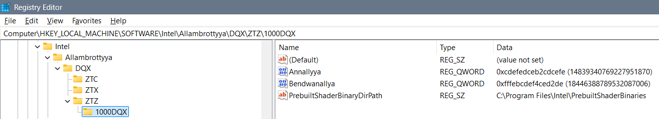

#### Allambrrorryttyyanallyyannyya

#### Ellembrosyyannallyyannyya

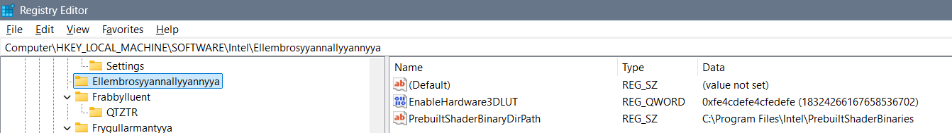

#### Frabbylluent

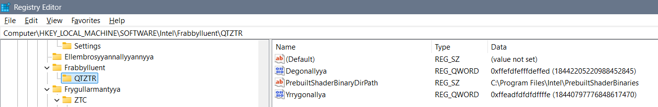

#### Frygullarmantyya

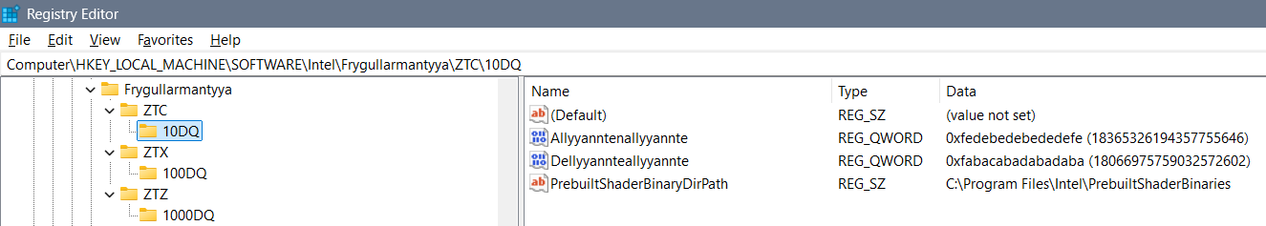

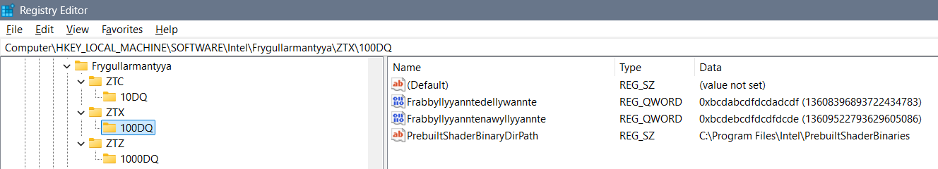

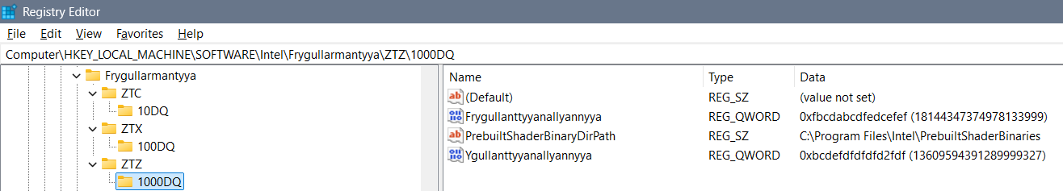

#### PRST

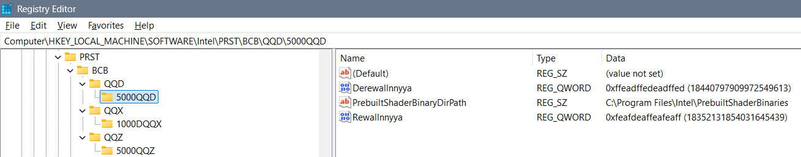

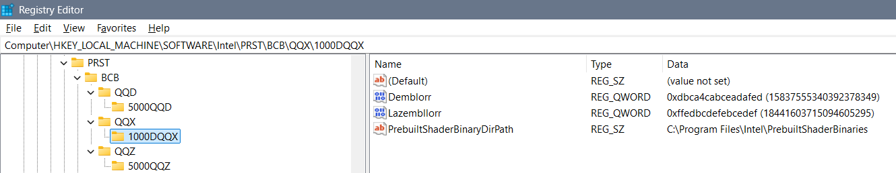

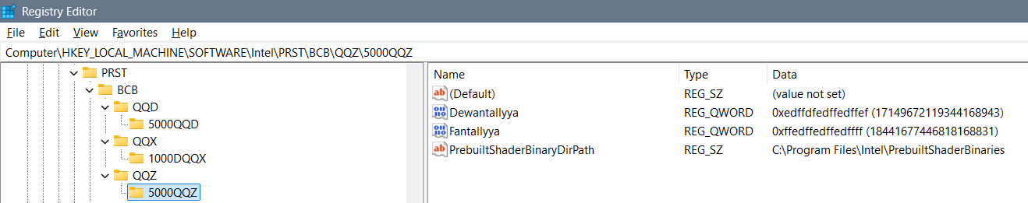

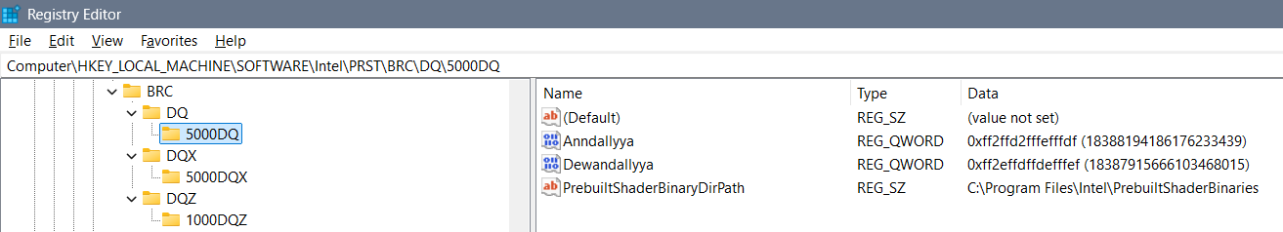

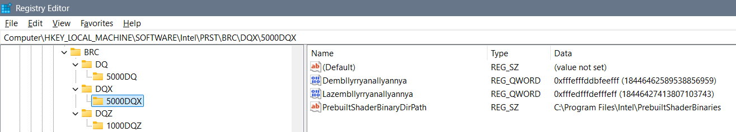

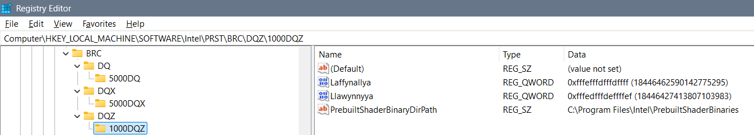

#### PTRST

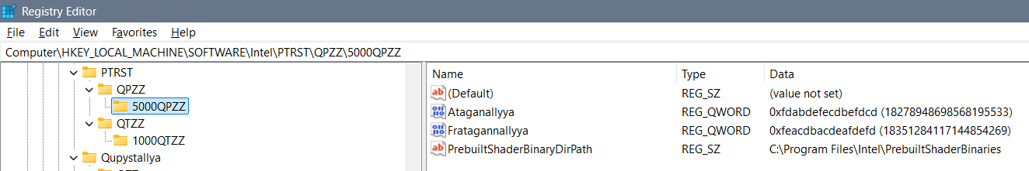

#### PTRST

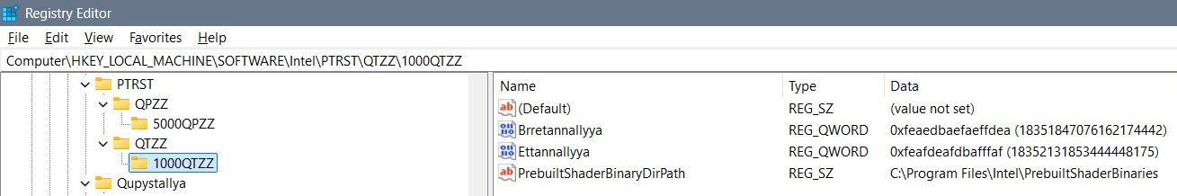

#### RMFTGXZ

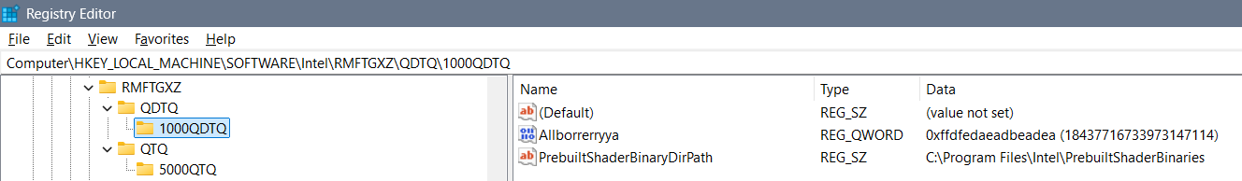

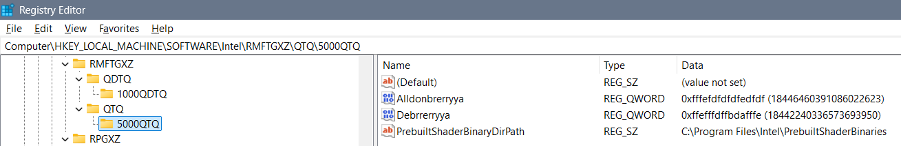

#### RPGXZ

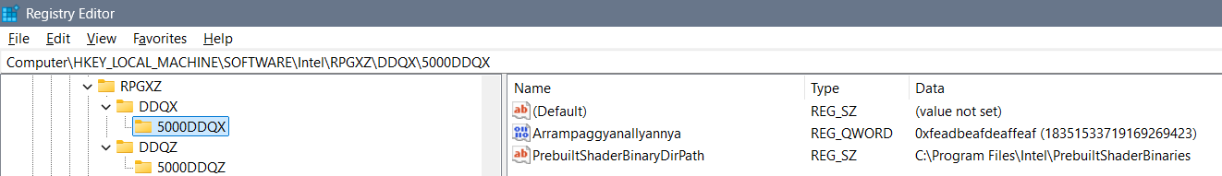

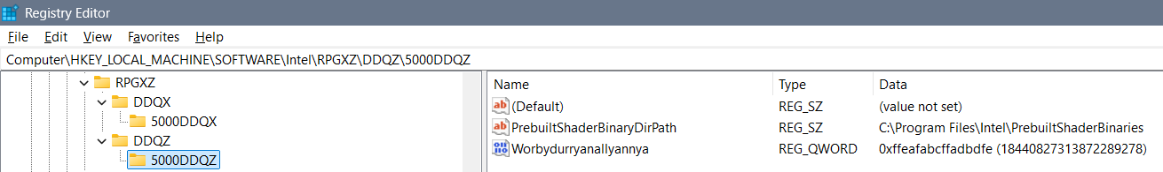

#### RTZT

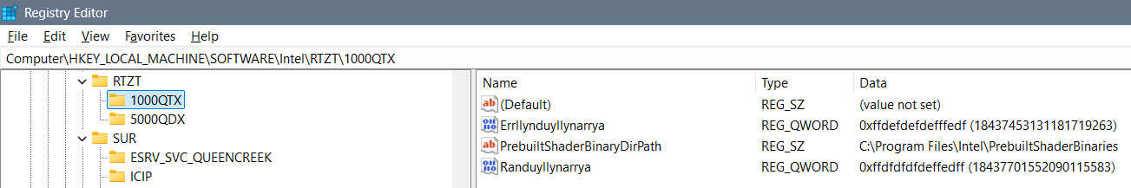

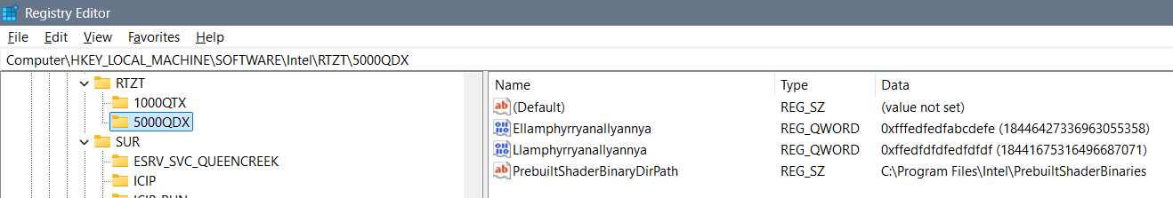

#### TRST

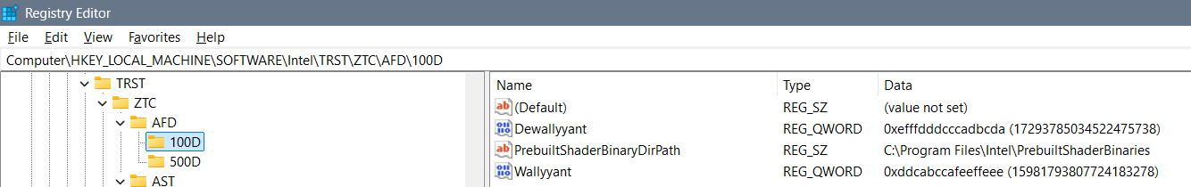

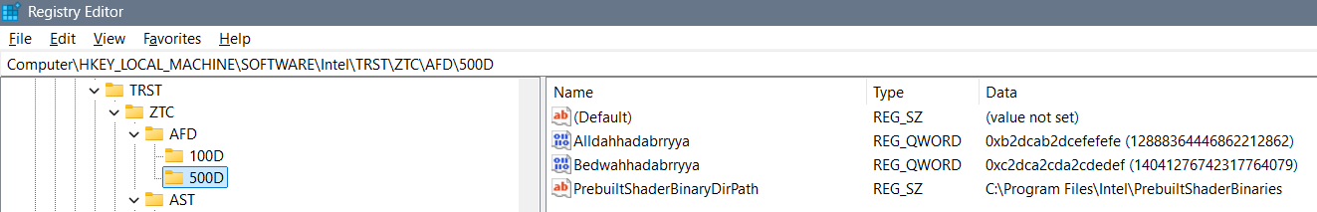

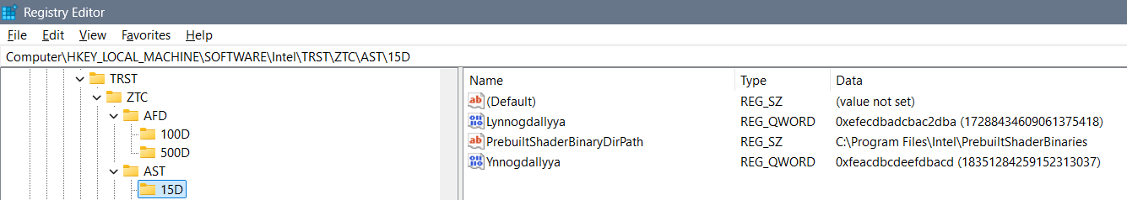

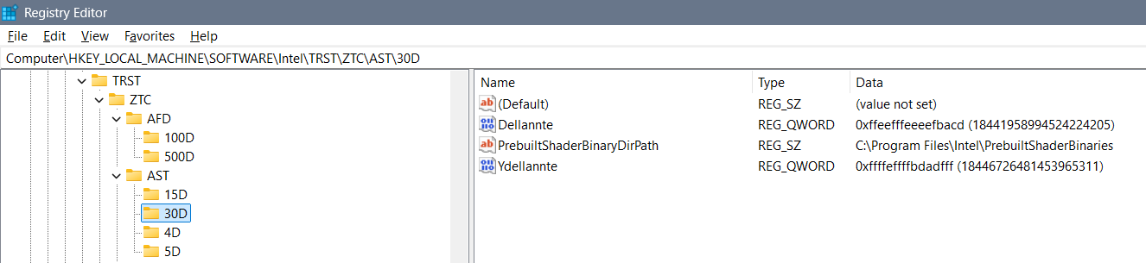 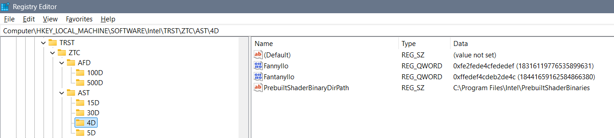

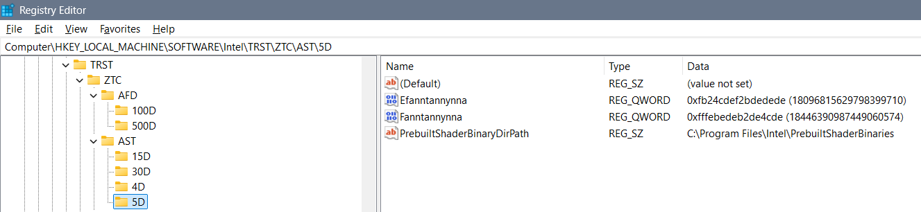

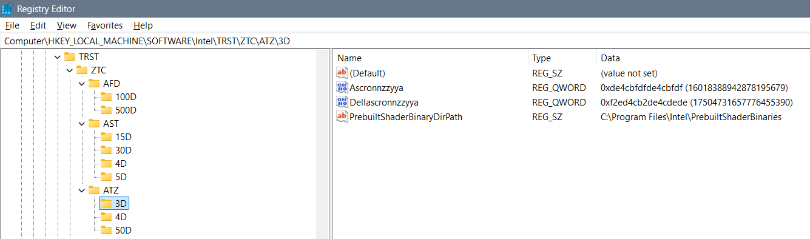

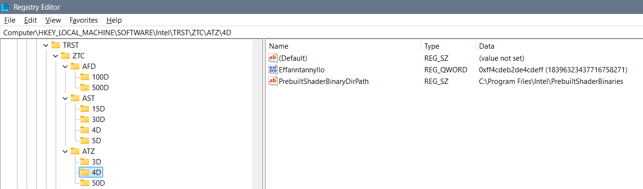

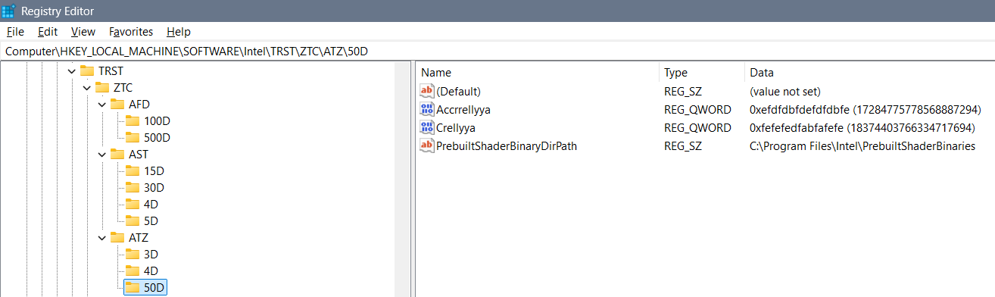

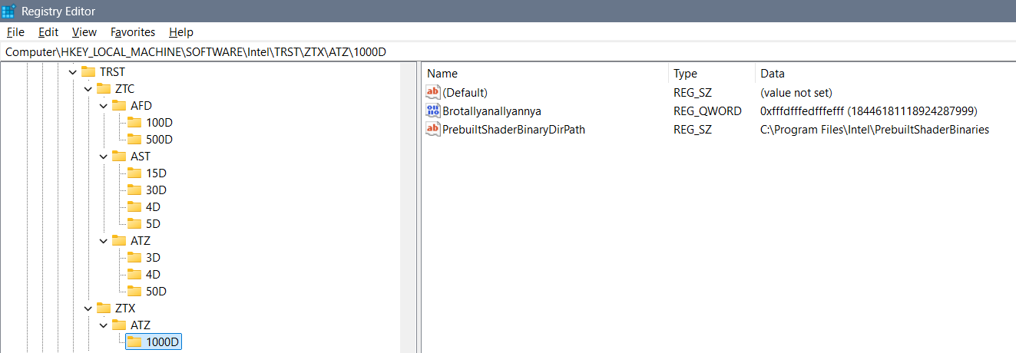

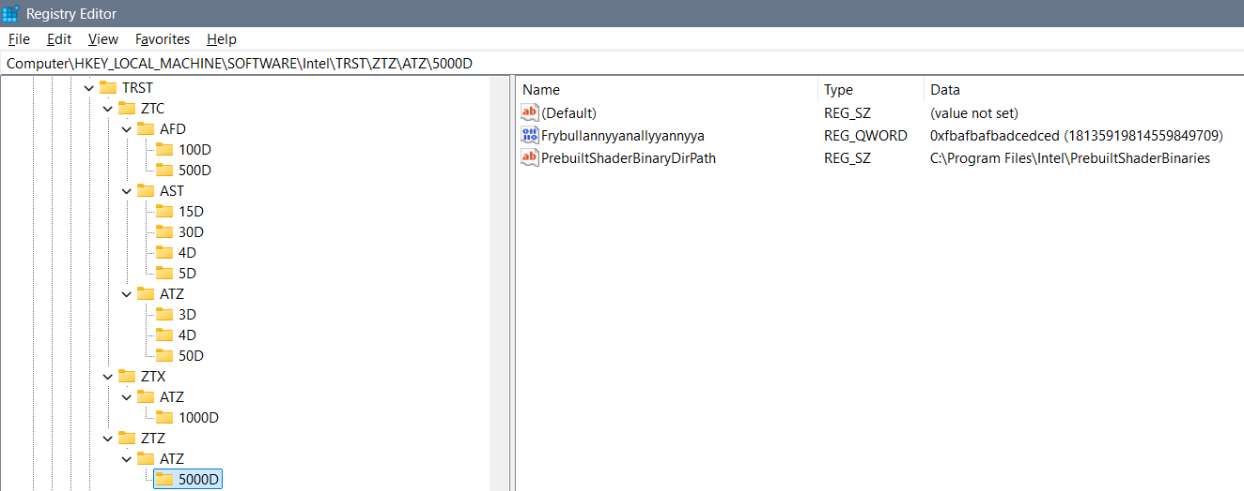

#### TZTRT

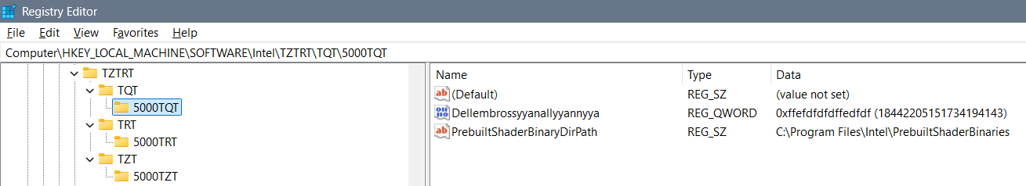

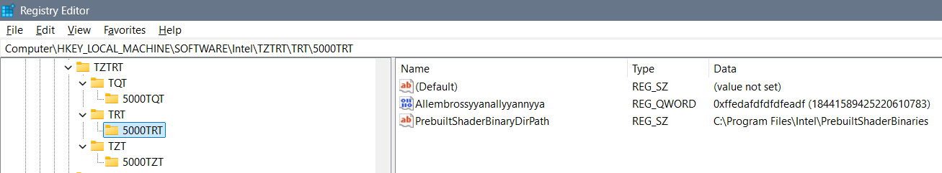

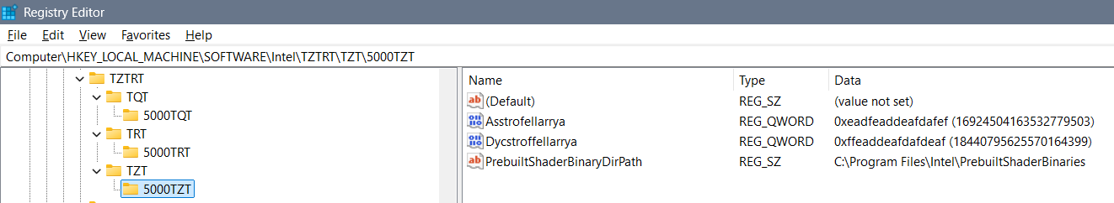

#### Zygollarmanttyyanallyannya

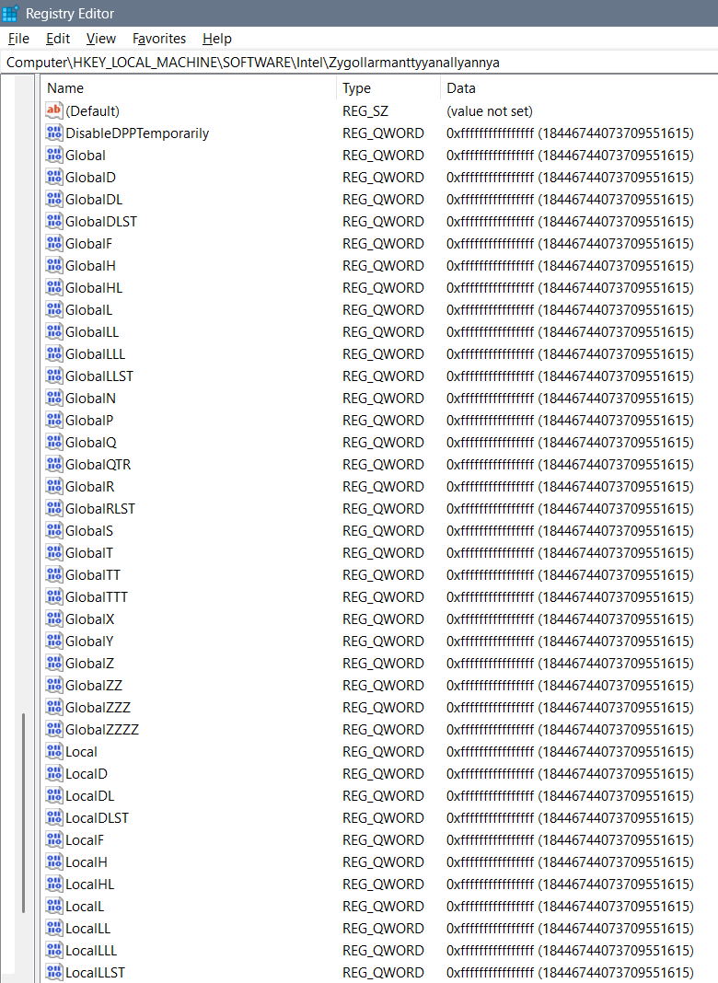

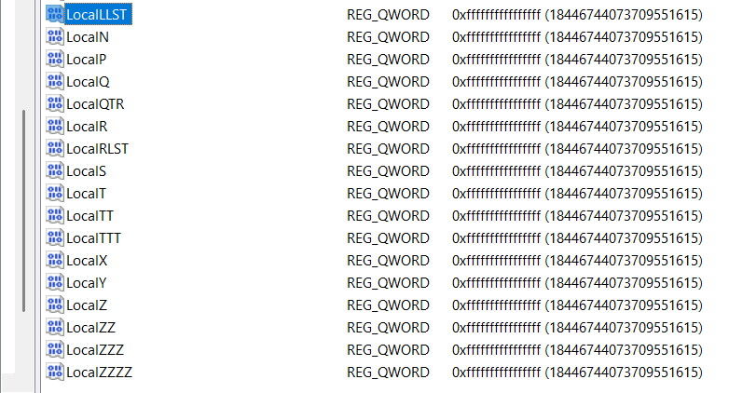

### “HKEY_CURRENT_USER\Software\Intel\Display\igfxcui”

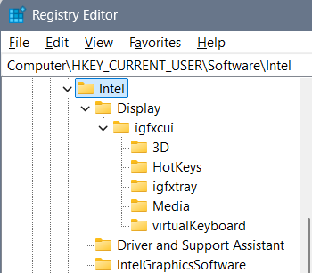

#### 3D

I have deleted the 3D folder and added a ban folder:

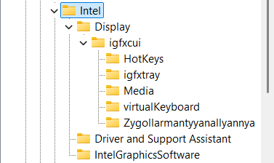

Old 3D folder is here:

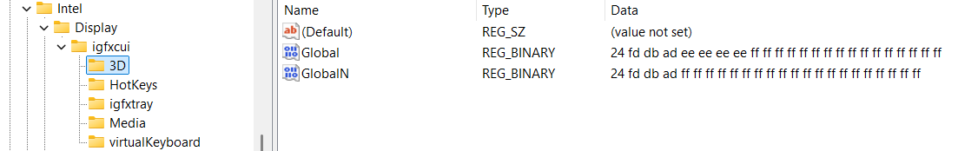

#### Display\igfxcui\Media

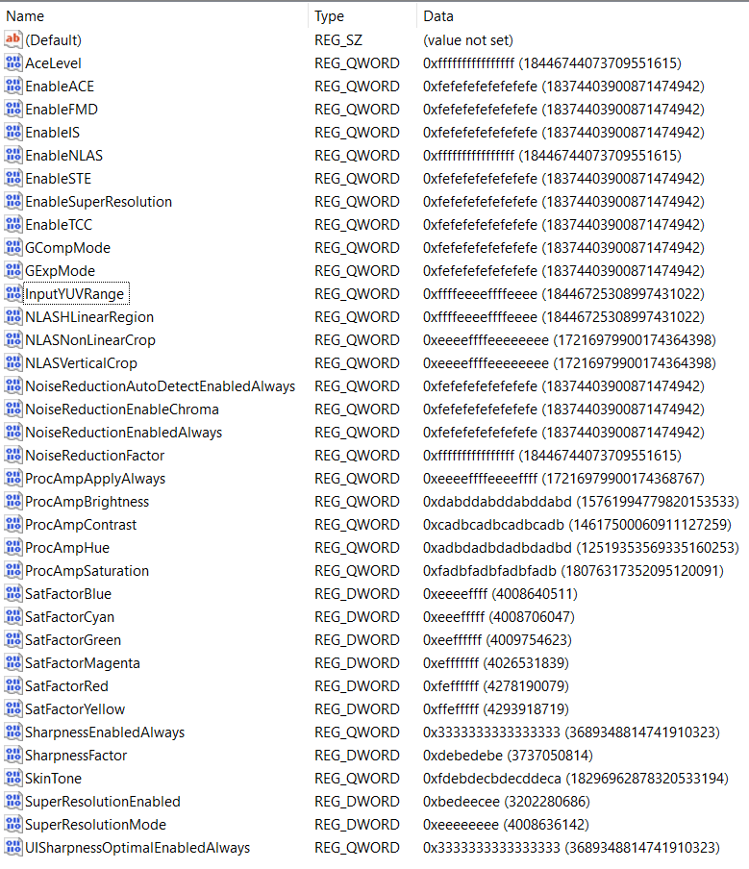

With these settings supported worlds are: Degrywallstacyonall world – of cosmos jokes that are appearing where they should, Yrrygacyannall world – of banners of what we are doing and what we should be doing, Acquezzystacyonall world – of beings worlds for us to investigate, and etc…

#### MISC

First option for “UserSetDRRSDisableRR”: the “ffffffffffffffff” value would take care of you and create you pleasant nice and kind – would take care of you always…

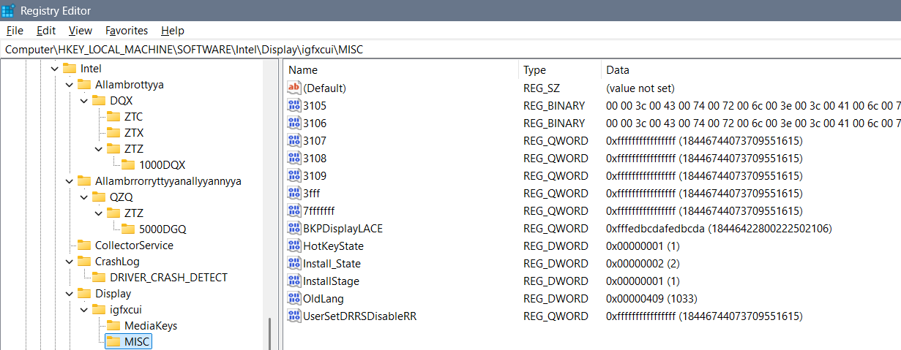

Second option is in kind of “live” as you are which we got used to mostly:

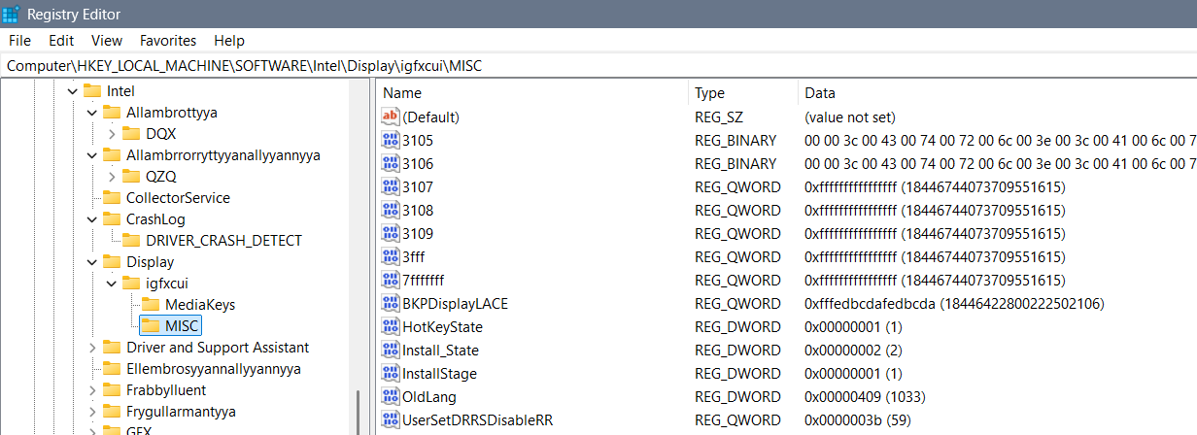

## Theory and explanation

Let’s talk about beginning idea how files can be shaped and changed and how they pull the system one way or another (from the computer, or to the computer) thanks to the settings we have...

Let’s talk about the Intel graphics card settings… Besides regular settings for brightness, contrast, saturation and hue, there are some more options under Registry Keys that you might find interesting for a better display view…

I believe that here a setting: “Enable…” or “…Enabled” (for example “EnableACE” or SuperResolutionEnabled”) doesn’t need to have only options 0 or 1, but it can have any possible options, and the point is that you actually play with the display settings and figure out when you have the best view… I will give you a hint – if you set everything else right – setting the “SkinTone” to a value “3” gives you somehow a feeling of “a Saint computer user”… So, the conclusion is that you can create anything that you like from these values without needing to restart the computer to see the results…

### Beginning idea of editing binary files

* Computer\HKEY_CURRENT_USER\SOFTWARE\Intel\Display\igfxcui\Media

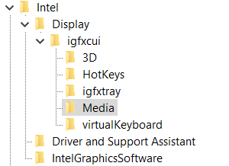

Those settings are mixed, coded, introvert – flipped upside down and mixed while flipping so while we are mixing them we get the word we want – and by the belief it has only one key… For example if we would start with an idea of repeating of hex values – fractal to cosmos – we can for nonsense start with for the non existing “DPA” key: “ff” would be fine, and “fff” would require 7 more “a” hex values for us to put DPA to Yrrygonallya model of understanding… Then if we would add another “e” we would need to type and “dbca” which gives us 8 hex values and the word “DPA” would be translated into Hex as: “fffedbca”. The point is to code as many letters as we can so that we get the desired idea…

All those settings are connected in some way – unknown for us, but by the belief maybe one DWORD after another … I believe that the code in one field is connected to the code to the other field and that the whole code of the registry editor file of the graphic card represents some type of the solution rather than those parts one by one…

At the time my settings that were are shown on this image:

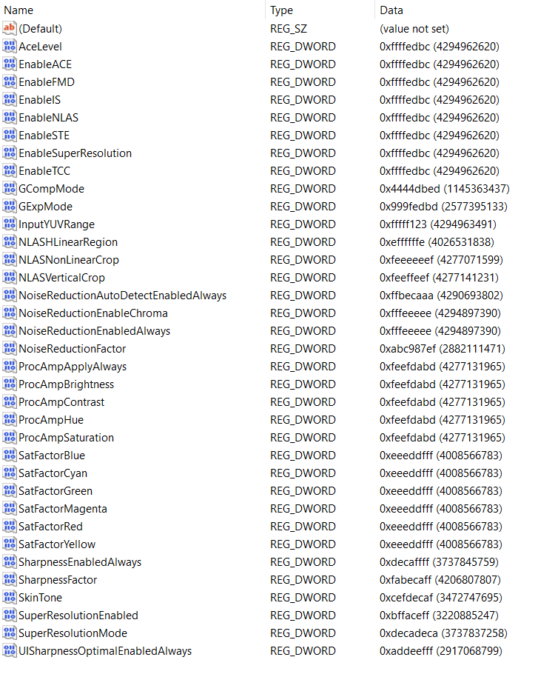

Type all “fffedbcdafedbcda” into the **BKPDisplayLACE** file:

* Computer\HKEY_LOCAL_MACHINE\SOFTWARE\Intel\Display\igfxcui\MISC
* Key: BKPDisplayLACE
* Setting: fffffffe
* ffffeeeeffffeeee
* Earlier setting: ffeedbc2defefefe
* Newest setting: fffedbcdafedbcda

Type all “fefeacff” into the **UserSetDRRSDisableRR** file:

* Computer\HKEY_LOCAL_MACHINE\SOFTWARE\Intel\Display\igfxcui\MISC
* Key: UserSetDRRSDisableRR
* Setting: fefeacff

Under “igfxcui” you there can even exist a folder named “dgfxcui” which is more primitive then “igfxcui” and is based on a cube graphics, and under it folder “3D” with some keys… In both folders there can be some of the keys, but I find only some necessary…

* Cosmos: f2bde2fe
* Twirl: dba2cca2
* Yrygonallya: ffd2ffee
* Degonallyya: f2bde4cd

Some of the keys have some abilities and some are too strong which is why we can use “Cartoon” instead of “cartooned”… Those keys can allow using of a system the wrong way – playing with it, which you might find unprofessional, but for some users maybe results well… When someone is playing with the system you should know that

* Cartooned: fe2bda2a
* Lymbralltyum: f2bcdaf2
* Mute: a2fedcae
* Muted: fe2edcae
* Cartoon: ffe2acde
* Descrywyall: fffc2def
* Stacyonarye:
* Estacyonarye: fffeddba

Maglow colors Elamphorenye light, Borrllandorr coding,

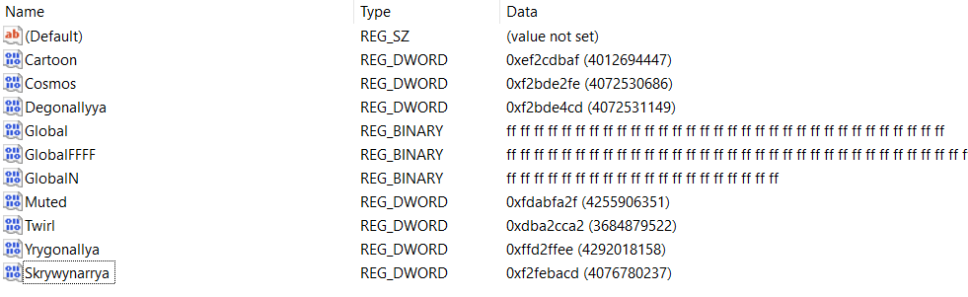

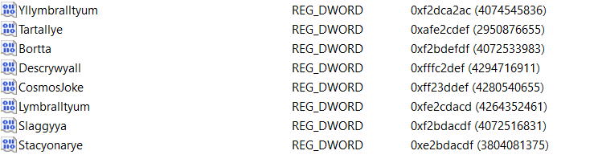

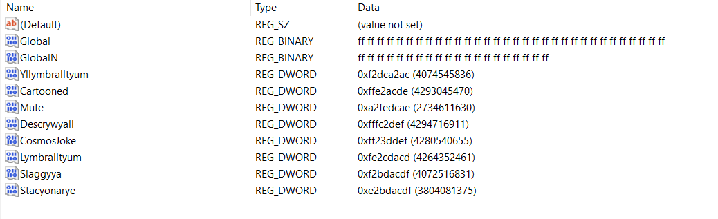

#### Computer\HKEY_CURRENT_USER\Software\Intel\Display\igfxcui\3D

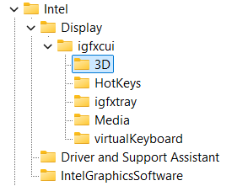

You need to type for the REG_BINARY named Global: 3 lines of “FF” code:

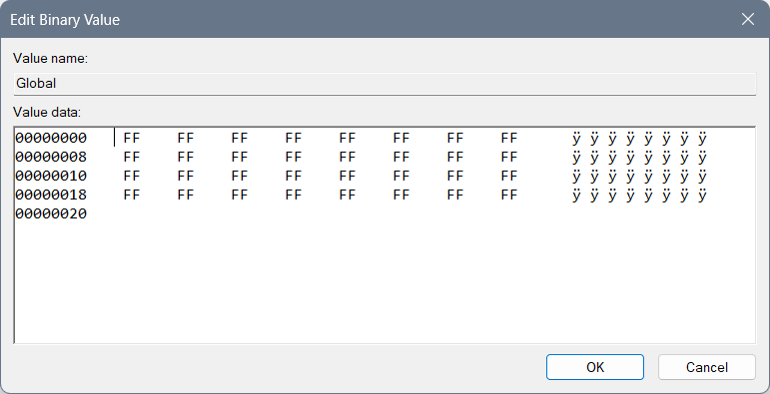

And for the REG_BINARY named GlobalN: 2 and a half lines of code of “FF”: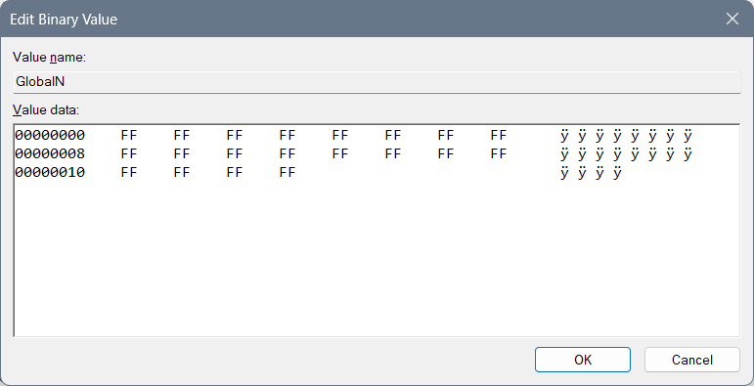

#### rgxfcui, drgfxcui, and etc.

Beginning idea of drgfxcui file:

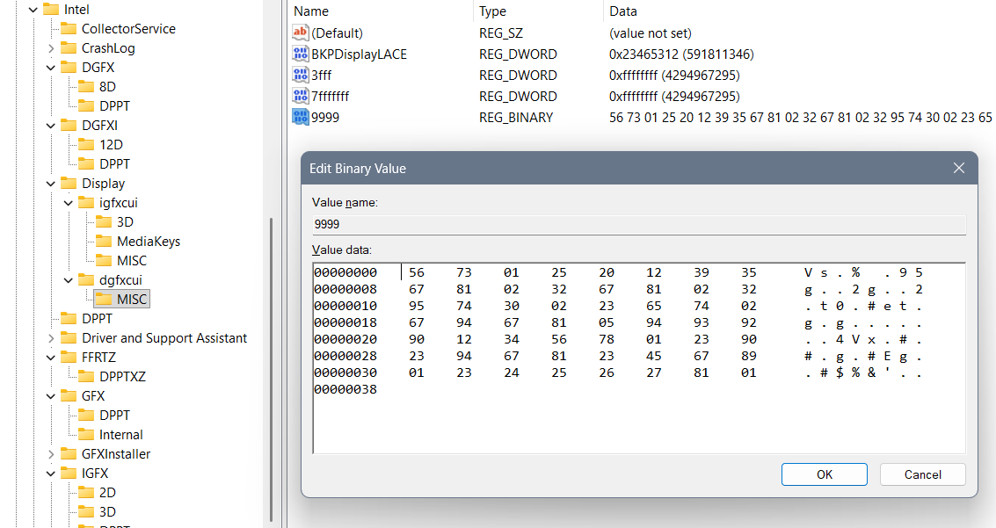

Represents Yrwenholl coding of the uncoded laptop describing every possible situation where cosmos jokes should appear and where shouldn’t. How user should behave and what user should do… It is in a dgfxcui file in a MISC folder, under a file Yrwenholl “9999” data – or a file named something like “Dataplet” (maybe “Datapllet”) or “Bazaplet” (or maybe “Bazapllet”)...

If you are not sure how each file is named, better not to create one like that, also if you are not sure how to fill it better not do it, and if you have shorter code as is REG_DWORD you should create one instead of REG_BINARY, but only if you are sure your code is smaller and it doesn’t have protection with simple bans and large bans as are “EE” or “FF”…

When we are typing long REG_BINARY files we should always pay attention to the system of letters we are typing according to the named files, because we do not want to create a mistake of open system reading everything that aliens didn’t allow, neither in the closed system… After you type many of the Chars you can find a mistake with a question – how can I actually do that to respect the system? And then you better not do it at all… There is another idea that you should do all of the code with Berllyngyerry (I believe being named so) coding with an idea to ban the system, which for Mergallyzyerry coding (of all files together giving a result) gives the extra hard task to do so…

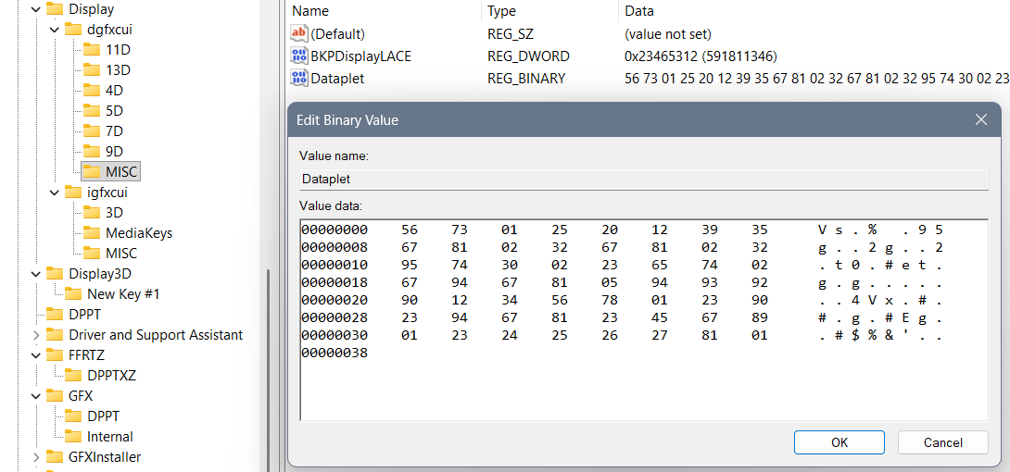

Example of maybe wrong system written codes:

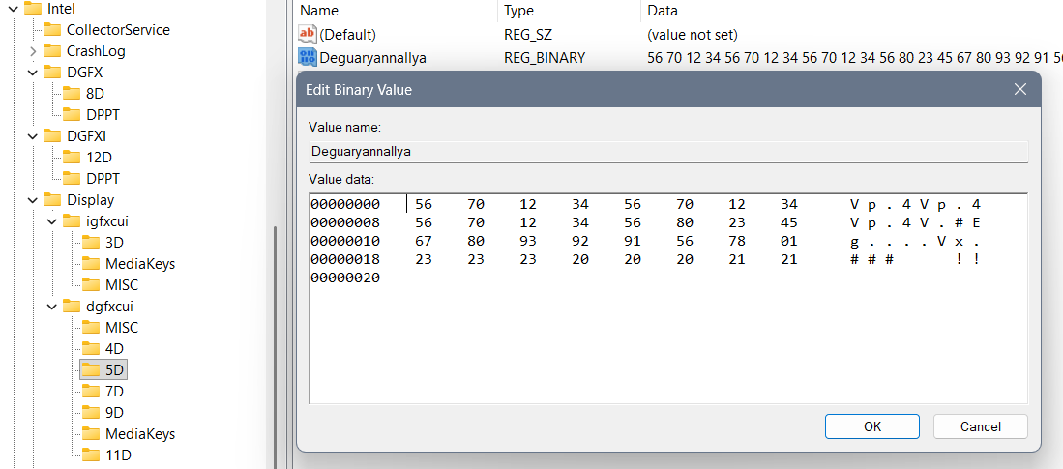

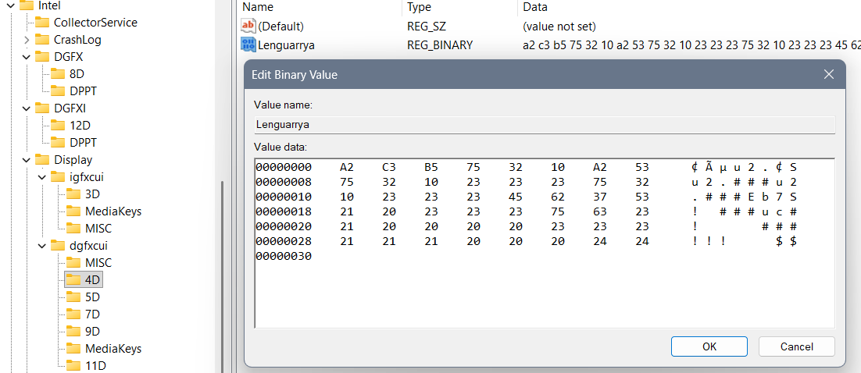

And the solutions:

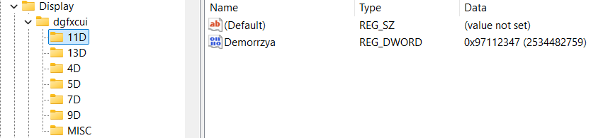 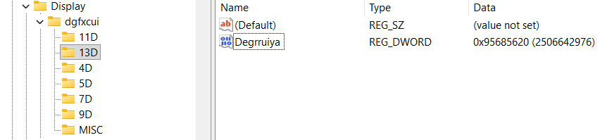

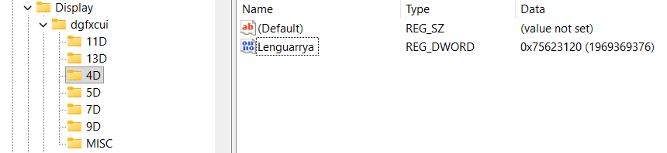

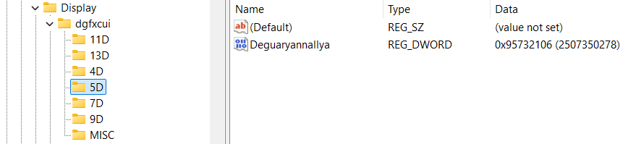

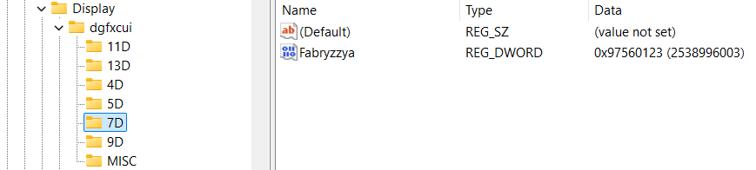

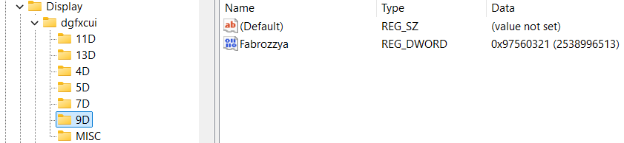

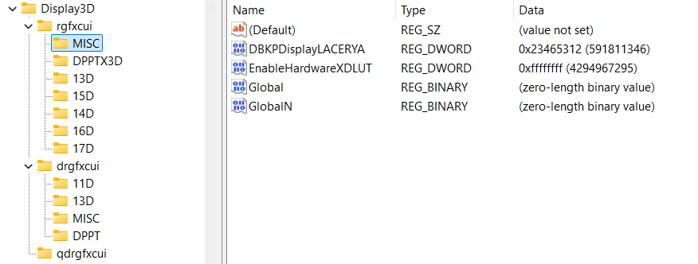

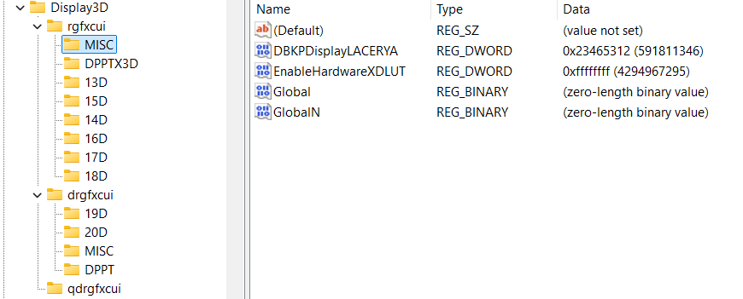

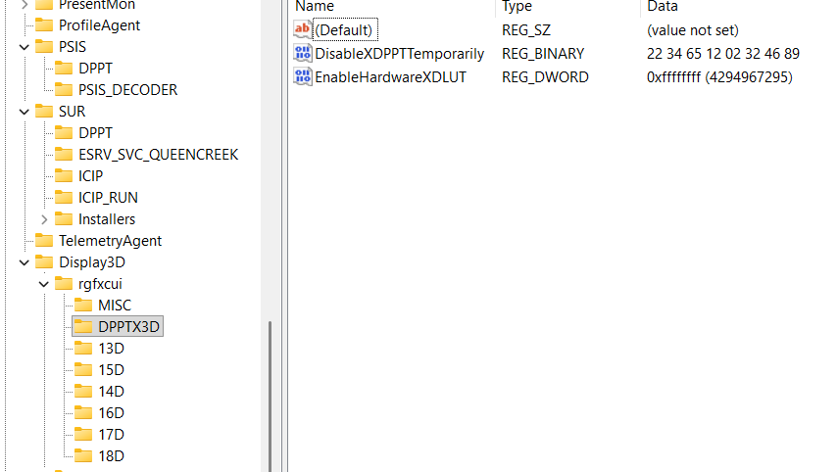

First of all those values were not that good… Not according to meaningful model as is cosmos (Yrrygonallya, Degonnallya) and first of all this values are short – DWORD and not QWORD which has their coding in question of their value…

#### IGFX\DPP

There is one more thing to add:

* Computer\HKEY_LOCAL_MACHINE\SOFTWARE\Intel\IGFX\DPP

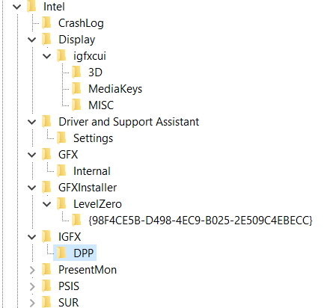

Suggested values:

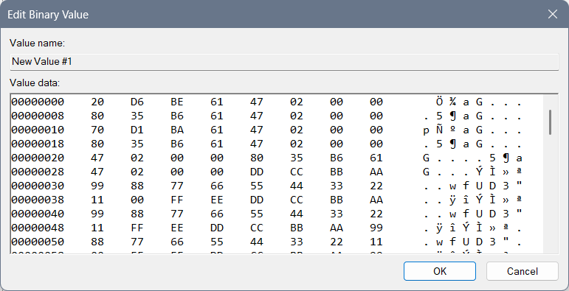

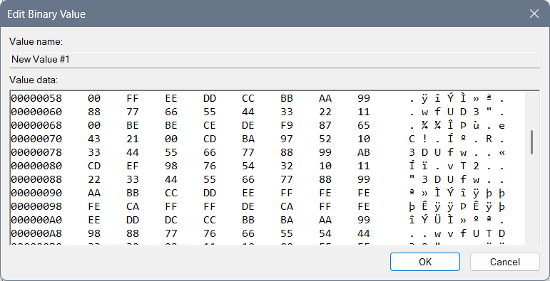

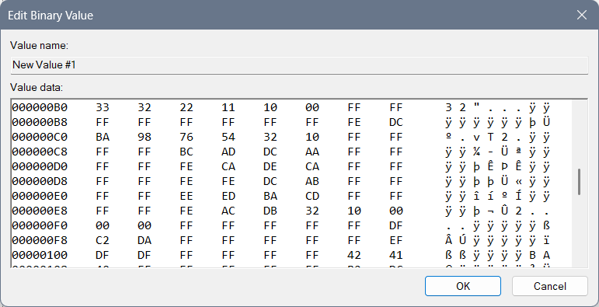 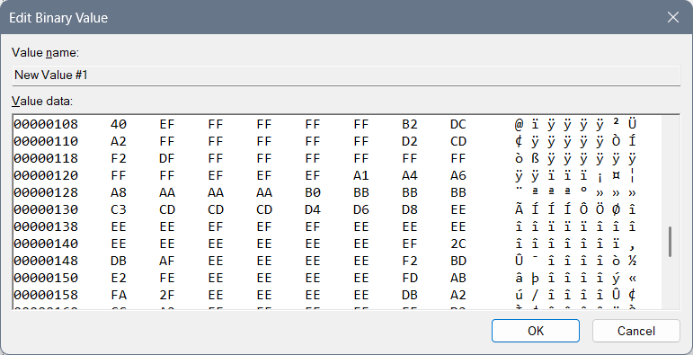 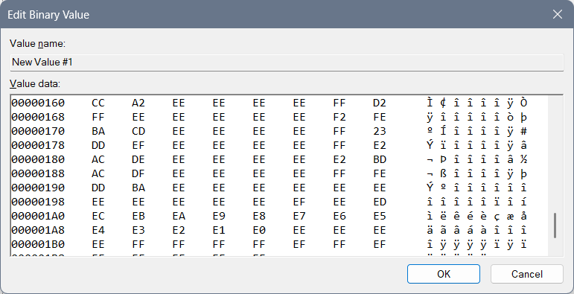 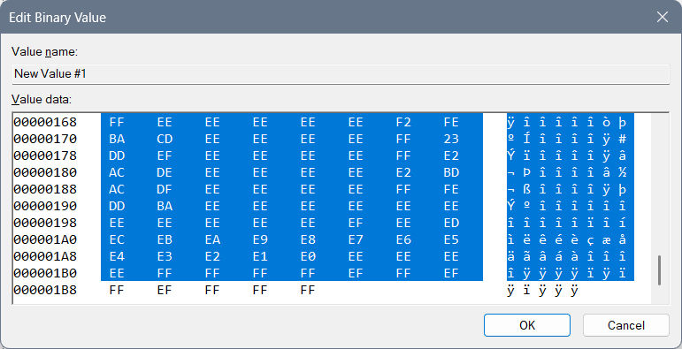

This code is based on some not fully made forbiddance (not fully made because it doesn’t give any descriptions or advices) with an idea that we start from the greatest letter “F” and if we mix and code the code into the “Yrrygonallya” complex model as is meaningful model “cosmos” we can get “FF”, then we want all the letters and numbers included so the first line of code is: “99 88 77 66 55 44 33 22 11 00 FF EE DD CC BB AA”, and if we start with numbers in coded and mixed Yrrygonallya we would get police protection, then letters would give us army protection… Second repeating of that line of code would normalize the protection and third would bring it to life…

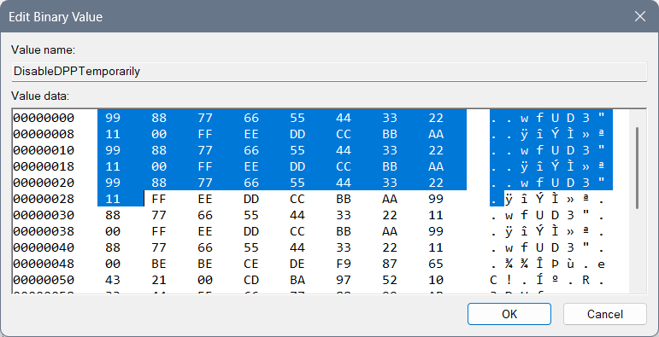Then we have the reducing of the protection to a regular level with these lines of code: 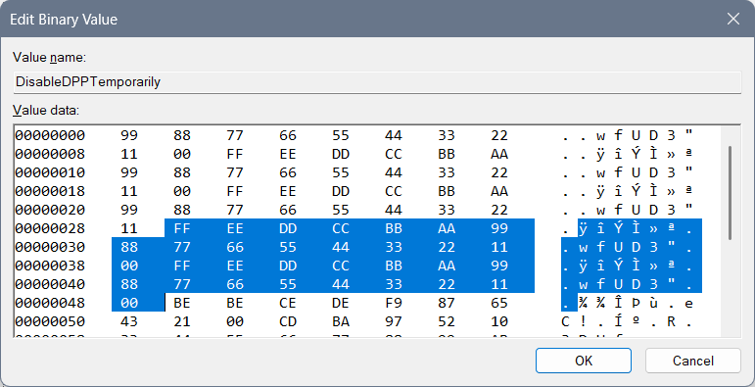

The next lines of code rarely few will understand, maybe even me…

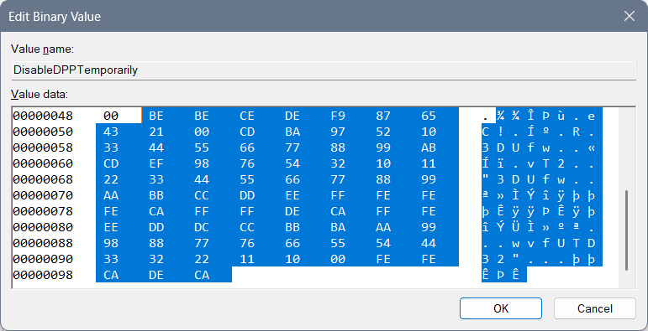 “BE” is “yrrygonall” (cosmos jokes left for the marks of meaning of something) code of the display for where we have been and what we have done… Double that would require a next chapter of code (so double that is prolonging of code) and if fully Hexa coded word fits into “Yrrygonallya” then after “BE BE” we would need to finish (as something that has been repeating – fractal, that fits into a particular model – for example “Yrrygonallya” or much simpler and better to understand “cosmos”) – “CE DE” which would mean extra complexing of the ban and the “descriptions to come” of those cosmos jokes appearing on the screen… “F9 87 65 43 21 00” would represent complexing of the data on the extreme level, so when we think on the level of imagining as much as we can achieve with our thought that much cosmos jokes would appear of what has been happening with us… “CD BA 97 52 10” represents how much we need and it says we need all of the data… You will find the name of the file “DPPT” – which by coding and mixing of the word and after playing with “Yrrygonallya” model and “fractal to cosmos” idea – we can find out that probably our data is complexed thanks to the previous code we had and after the “BE BE CE DE F9 87 65 43 21 00” if we connect what is there repeating of a single hexa digit as is for example “0” – “1”, and implement that into the “CD BA” we would get the vertical rectangle with the data included as is: “97 52 10” meaning: “only necessary data to appear, in short sentences that are complete”… That Extrapollation of the data we would get with increasing the:

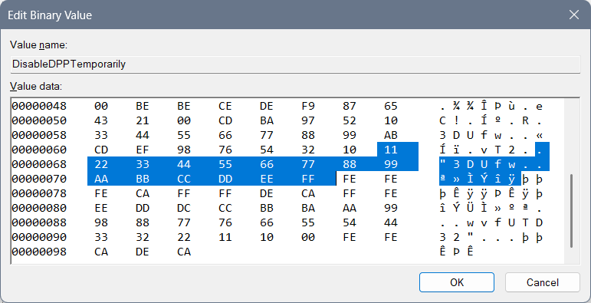

After that I have typed a complete and most complex ban of that data: “FE FE FE CA”, and allowing of the data: “FF FF DE CA”… “FFF EEE DDD CCC BBB AAA 999 888 777 666 555 444 333 222 1111 000” relies on complexing the need of the data showing and the variety of an ideas for the data to appear thanks to how we are feeling… “FE FE CA DE CA” has something to do with 3DLUT and it is connection part to the complexed data in between “3DLUT” and the “DPPT”…

From Cosmos History “Mergallyezzerrye” named being (belonging to DezAllystawrya model for beings) coding involves coding all files into the scheme of code, how only computer knows to get a real result… That idea “How computer knows” is named “Berslanderr” coding… “Berslanderr” is a name of “NaxAllystawrya” being that was thinking about the idea how all files can be connected all together by implementing a coding algorithm to connect all files and even for a computer to have an idea of implementing files for which particular devices don’t have a written specification…

Mergallyzzarye code connects the data all together – one file with another where one file is coded by implementing the extrapolation of the hex values from “0” to “F” and getting full word of 8 hex values, and all those files together in the end need to make sense…

Boffer code – is for how coded the code is – 8 times “FF” for the stopping of the device, 4 times “FF” in between the “density lines” – the meaningful part of the code… Effer code – represents the values that are “spinning in circle” – and are used to get extrapolation of the data that comes to our mind… Deffer code is there to explain everything and to give a meaning to hex values, hex files and is even able to create the new files and implement them into a code (here “Registry editor”) even if those files are not planned… Noffer code is there to represent the connection even in between the stopping code and the values in between, and in between the mixure of 3D ideas of the files where we mix both of the hex values of one file with another to get the idea of the 3D image…

To be honest that 3D image is there to represent cosmos joke that we can see on the display or the one that we can learn intuitively. The point is that those things we are doing, we can pull from the smart system and we can learn them efficiently… The system doesn’t need to be enabled at all, but by the regulations of the design we are there to at least learn to behave the way the design is requiring...

#### 3DLUT settings are:

* “EnableHardware3DLUT” setting should be in the correlation with the ending of the file “DPPT” and those 2 codes should somehow represent life…

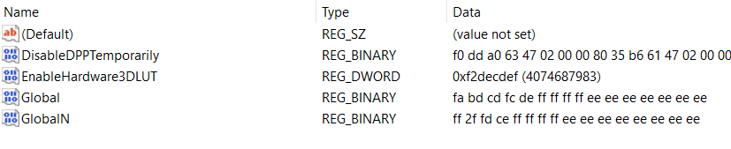

##### Previous not pleasing values ideas:

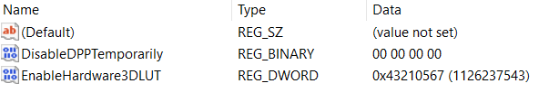

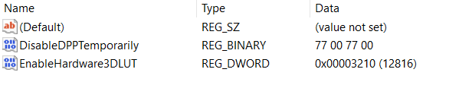

DWORD: “EnableHardware3DLUT”:

* For underworld codes which are maybe only for the environment around you: 43210567
* Life with begging: 56710234
* For 3D feeling for no reason: 22224411
* Fine for work: 75692320
* For shutting down the wrong things: 3210
* For turning on the thinking idea: 6543210
* For necessary: 43210
* Night light: Ban, fun, entertainment: 23153021
* Night light: Life: fdbacdaf
* No Exit: 0xaaaaaaa0

Interesting undefined ideas for the 3DLUT settings are:

* cdafccfc
* 23153021
* bebeca
* cebebeca
* cacabeca
* ffffedca
* Complexed: decabeca
* Fbacdfaf
* fffedbca
* fbacdfaf
* ff2a4cdf

#### New keys

Computer\HKEY_LOCAL_MACHINE\SOFTWARE\Intel\IGFX\DPPT

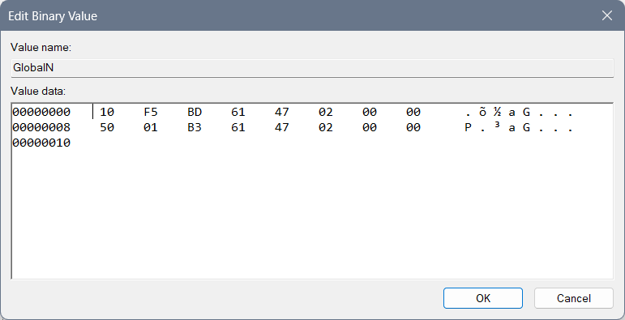

#### Post scriptum

Here you can find my previous, not well made, settings of the address:

* Computer\HKEY_CURRENT_USER\Software\Intel\Display\igfxcui\Media

You can look at these images down below just for informational purposes…

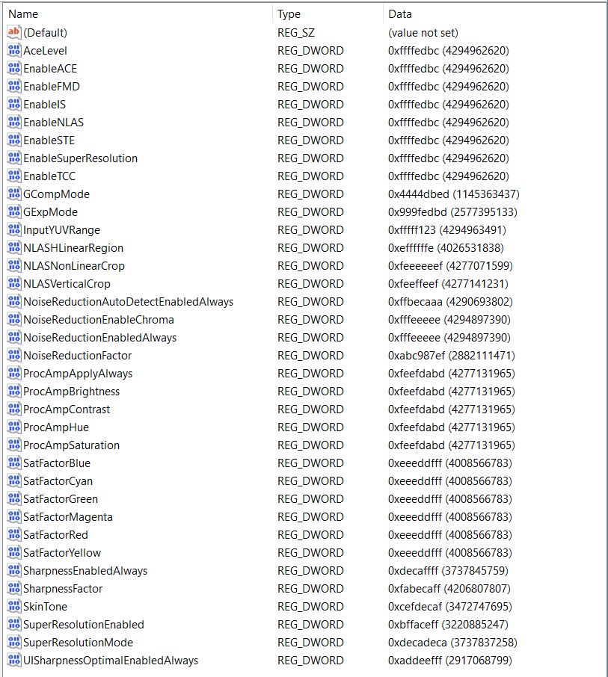

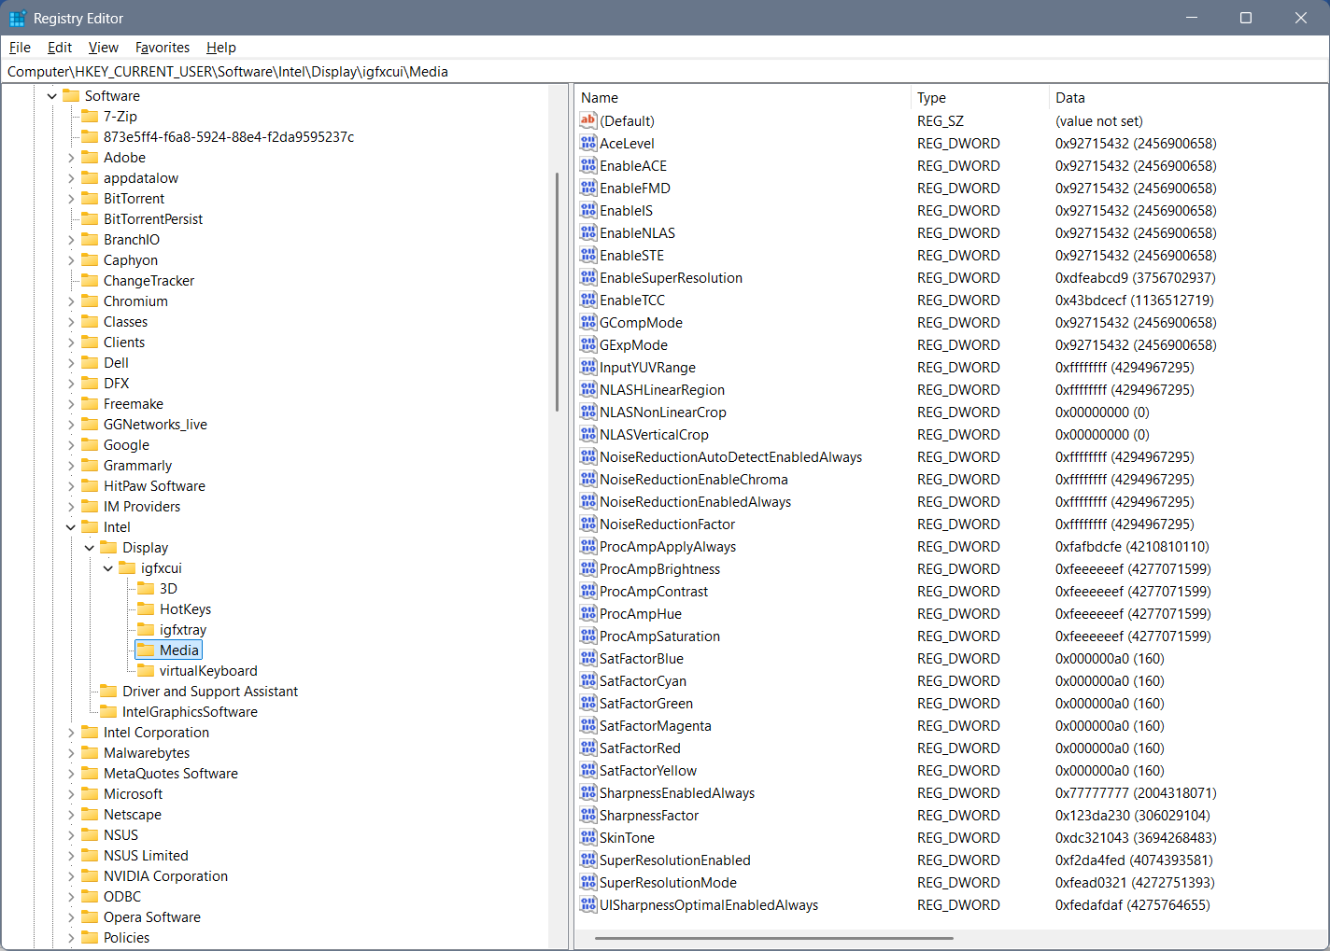

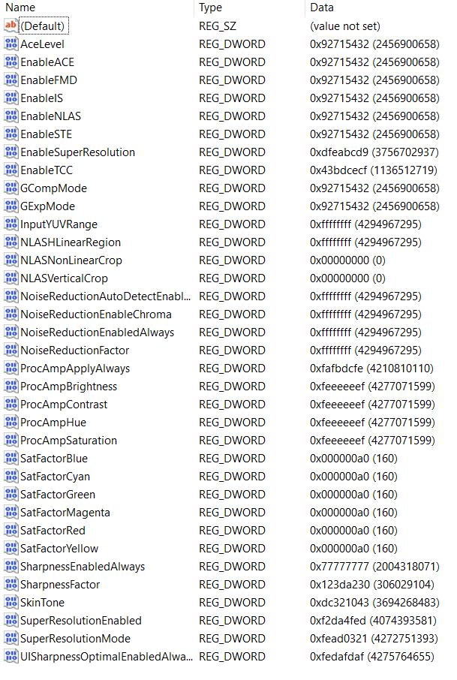

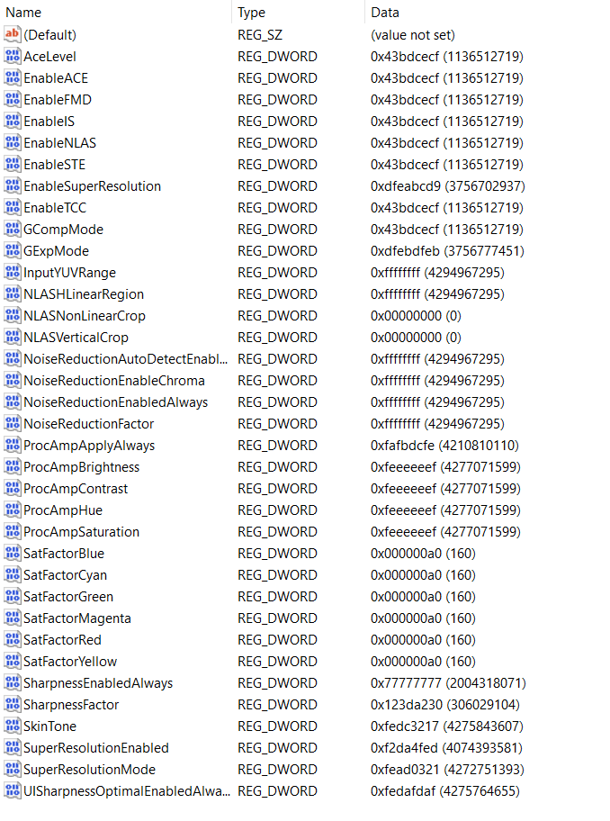

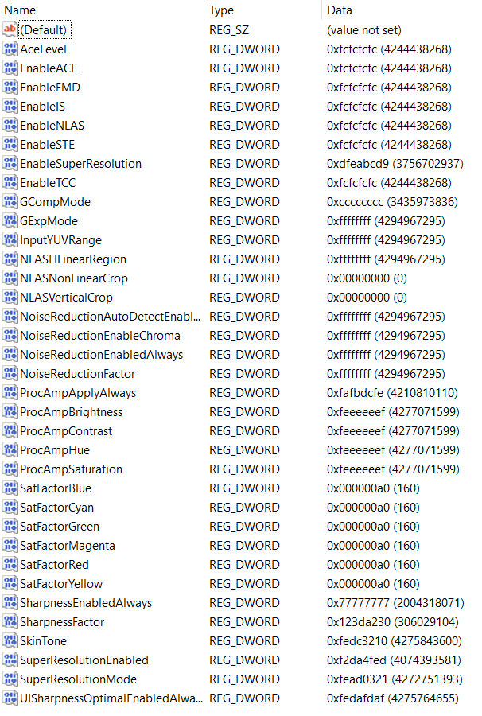

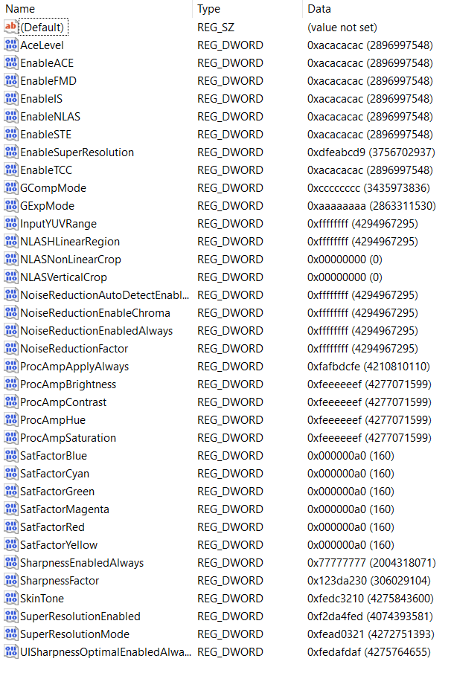

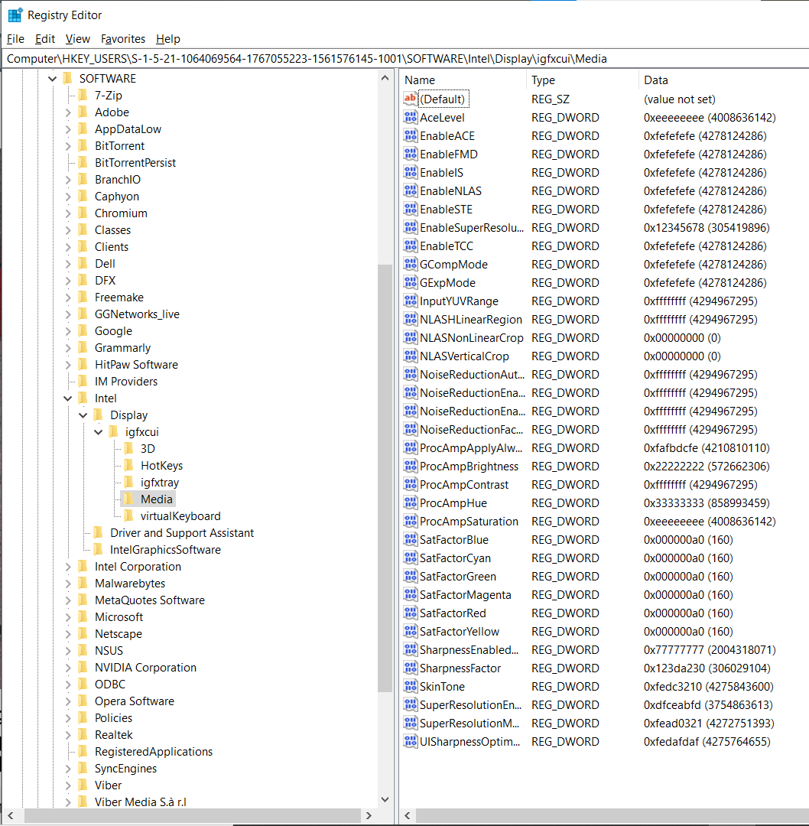

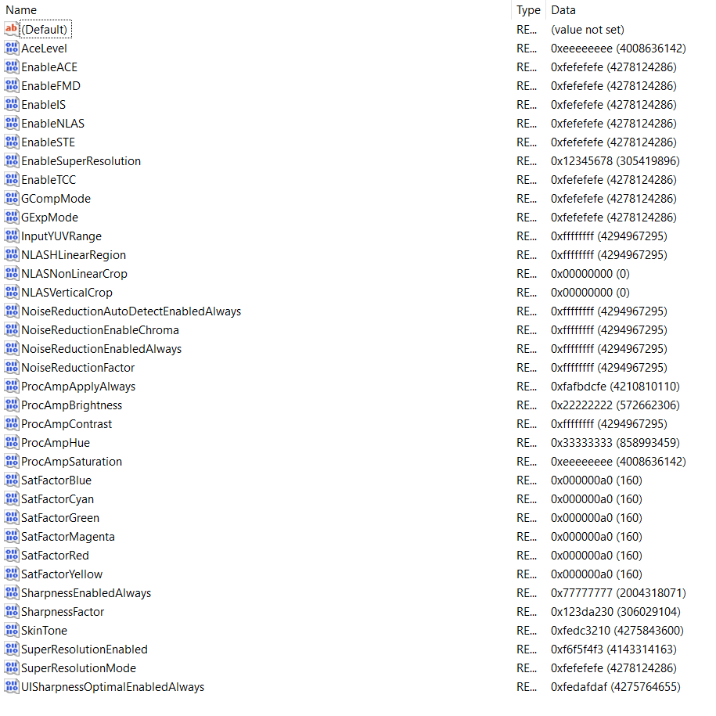

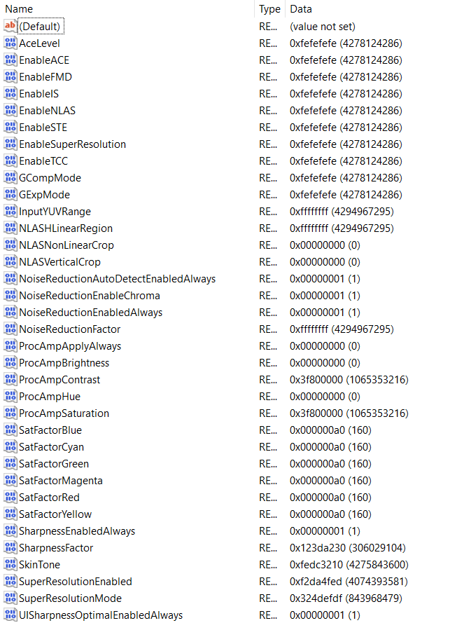

#### FFRTXZ

##### DPPTXZ

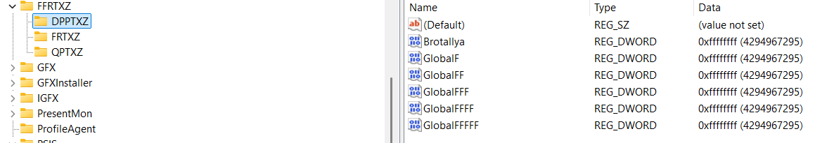

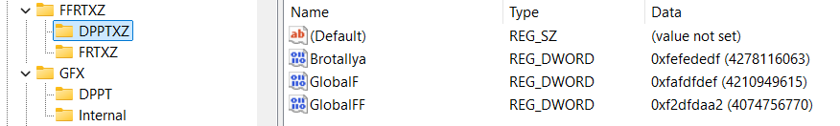

##### FRTXZ

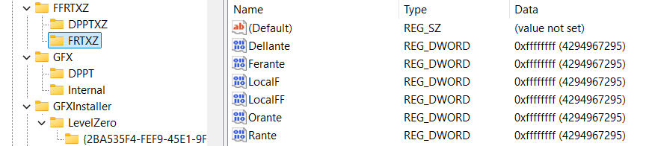

If you want to allow:

* Dellante you should use “fafadafa” (as some primitive planets knew so) or “fefedefe”…
* Rante: 2a2a2a2a, 2b2adca2
* Orante: 23232323, f23dbaf2
* Ferante: fdffdfdf
* Adyllante: f2dcabfd, fbdcafdb

Earlier values not implemented are for “Global”: “F2DF2AF2” – extrowallyattarry ban – on all and everything but reading only allowed things… For the file “GlobalN”: “AFDFEDDF” we have Nonbralltyya ban on reading banned things… Because you do actually need to ban idea of global (usually alien reading for smart beings) and there are “symbols” (words)

##### QPTXZ

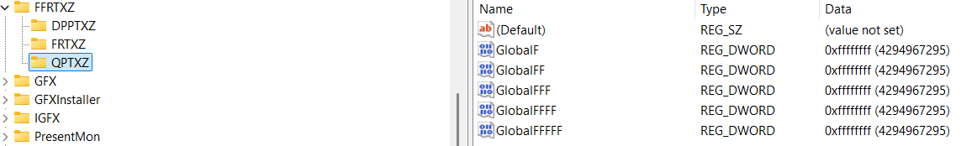

### “HKEY_LOCAL_MACHINE\SOFTWARE\Intel” Folders

Under a key: “Computer\HKEY_LOCAL_MACHINE\SOFTWARE\Intel” I had these keys:

* DDRTZ
  + DPPT
* DGFX
  + 6D
  + 7D
  + 8D
  + DPPT
* DGFXI
  + 9D
  + 10D
  + 11D
  + 12D
* DPPT
* FFRTZ
  + DPPTXZ
  + FRTXZ
* GFX
  + DPPT
* IGFX
  + 2D
  + 3D
  + 4D
  + 5D
  + DPP
  + DPPT
* PSIS
  + DPPT
* SUR
  + DPPT
* DRGFXZ
  + MISC
  + DPPTXZ

Notice that under the Key “IGFX” there is a Key “DPP”, I renamed it to “DPPT” for the hope of a better system… But that didn’t help much… The point is that connected Keys and the Data in the QWORD creates a fully valued system and some long words can’t be usually shortened to a programmed code as is “DRTZ” from the “Deggennerreyyazzattyonall” – which means involvement of the watches…

Under below you will find the images of the files with codes you need to open and fill into Registry Editor.

When you find a “REG_DWORD” file named: “EnableHardware3DLUT” you should rename it to the “EnableHardwareDLUT”.

#### Old photos and some of the values:

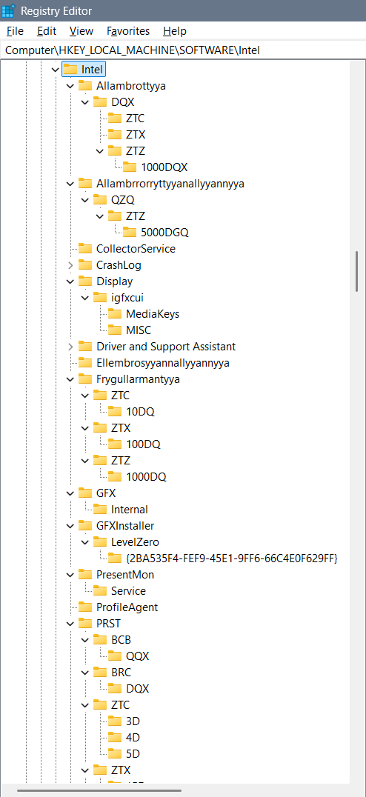

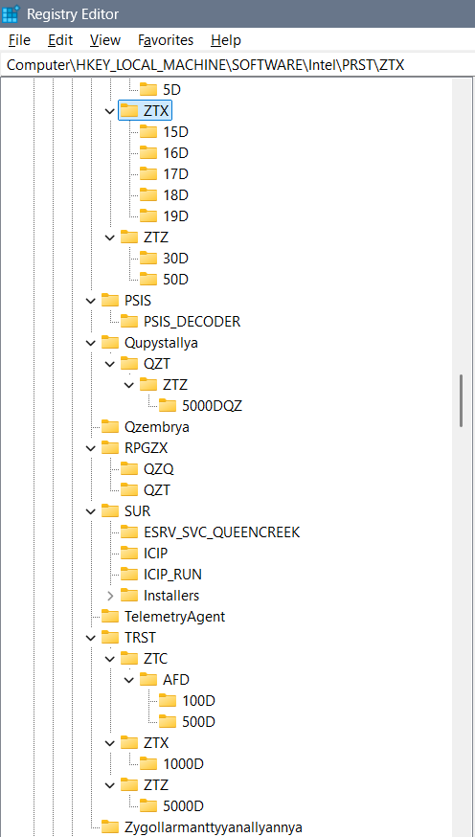

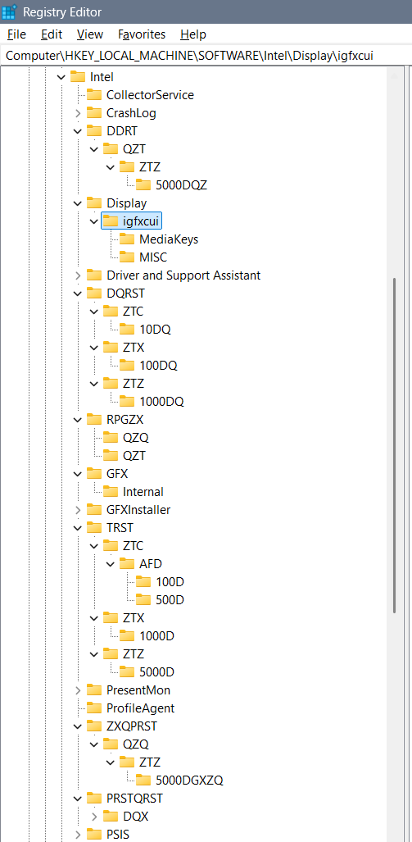

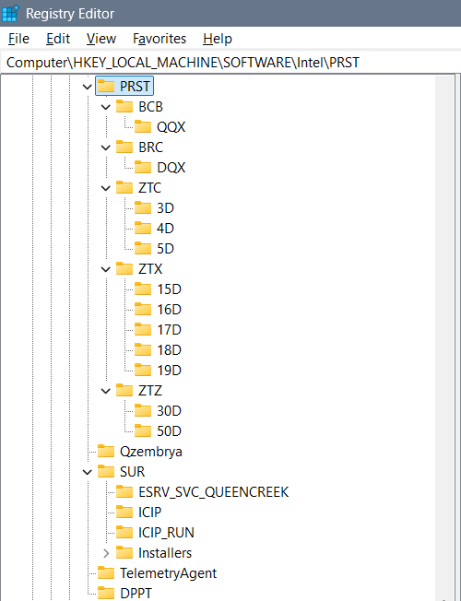

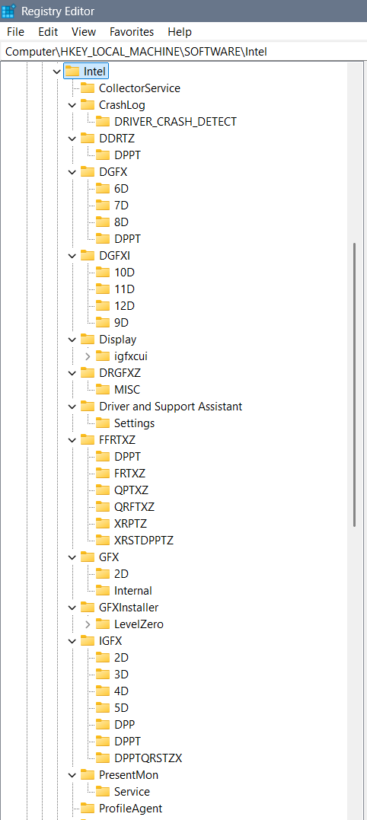

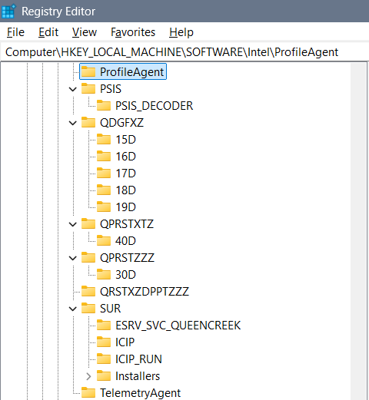

#### DGFX

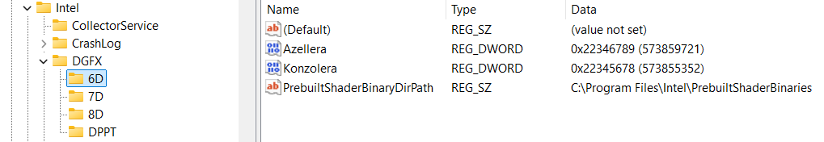

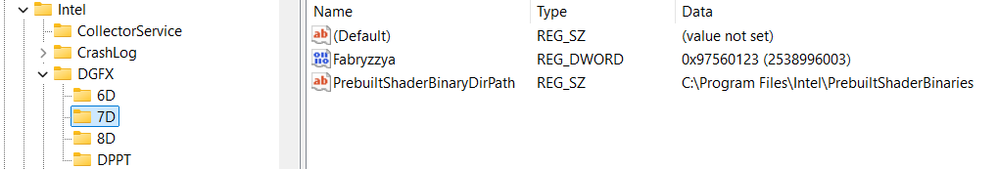

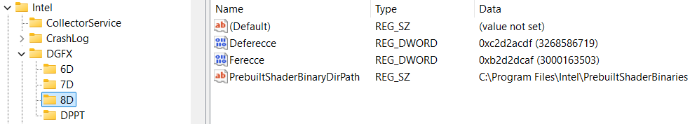

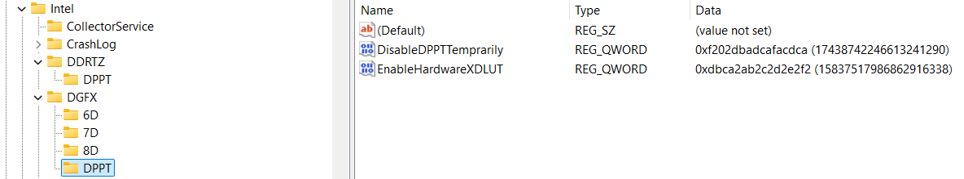

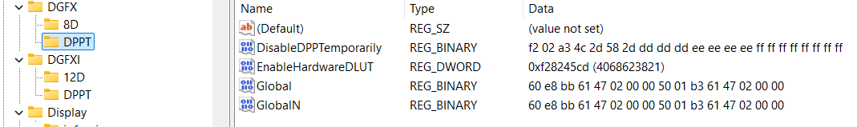

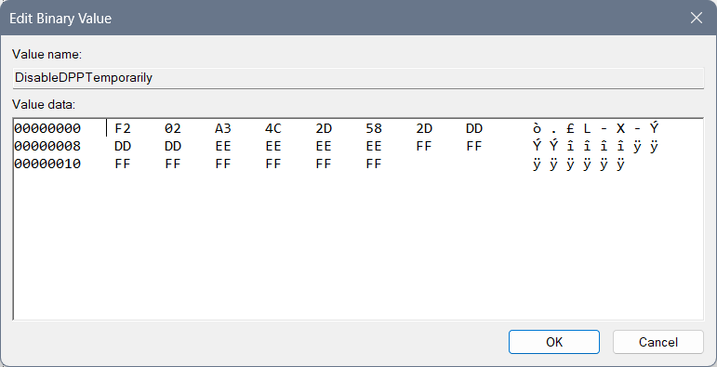

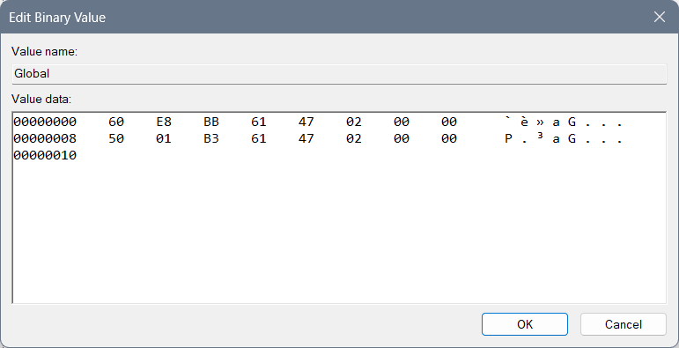

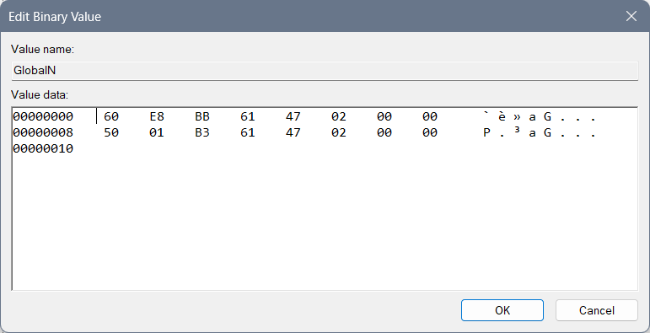

#### DGFXI

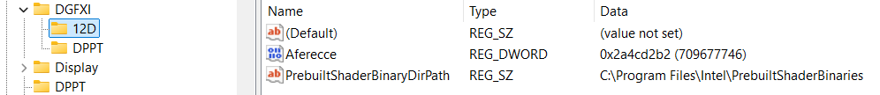

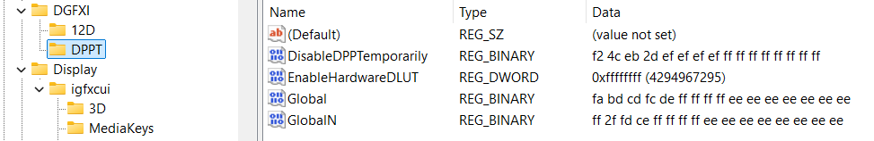

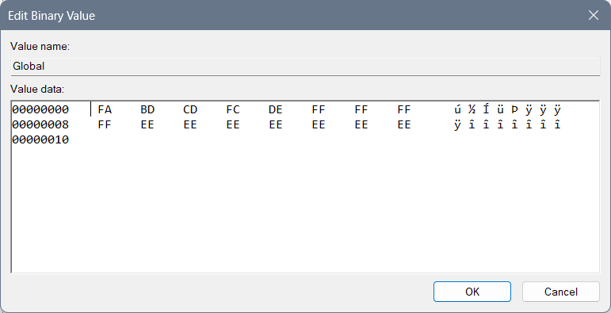

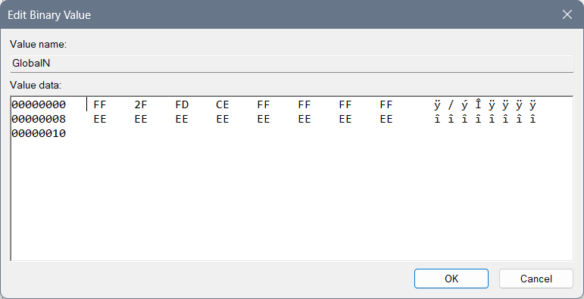

#### DPPT

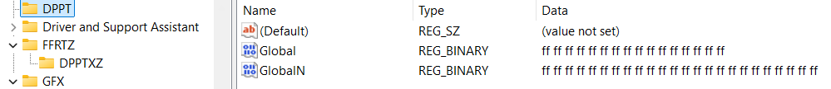

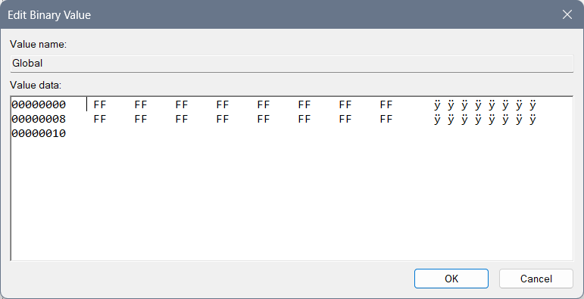

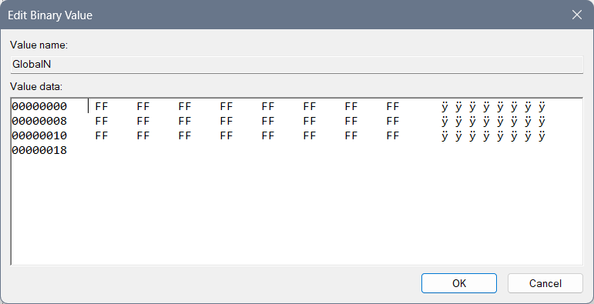

#### GFX

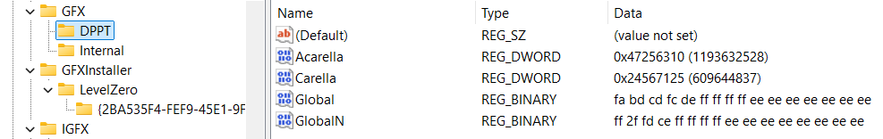

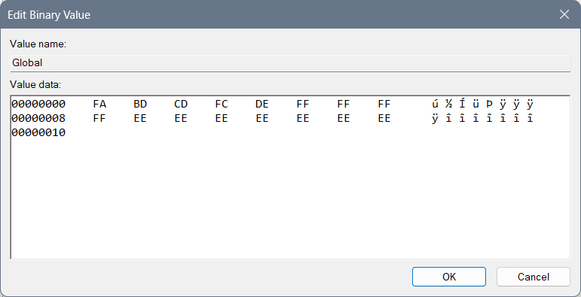



#### IGFX

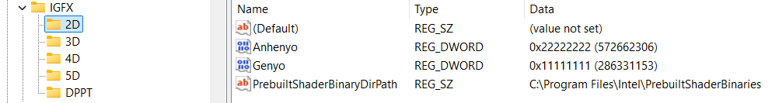

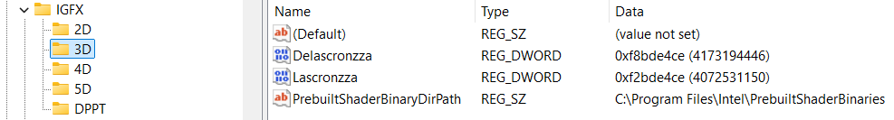

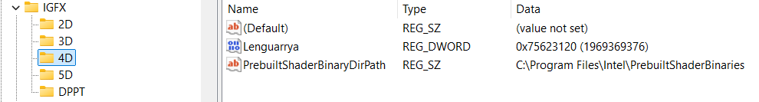

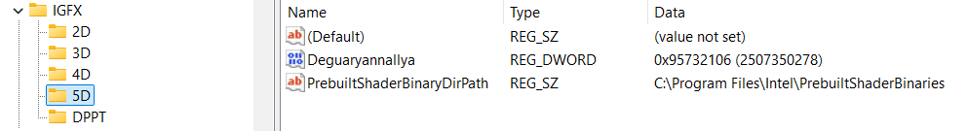

##### DPPT

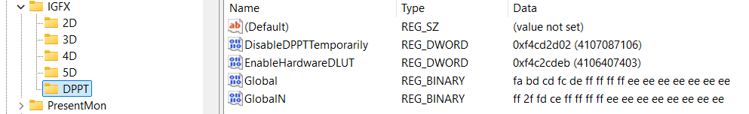

Or different idea of the DPPT which cuts the system differently:

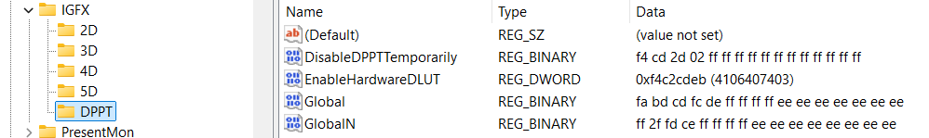

##### DPPTXZ

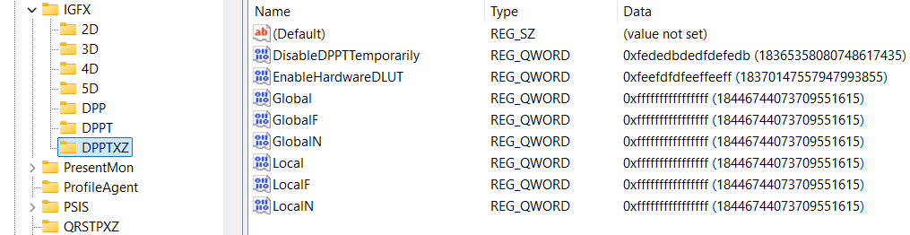

##### DPP

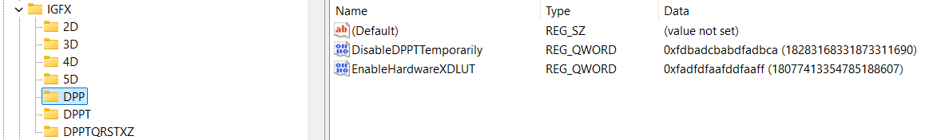

#### DPPTQXRSTZ

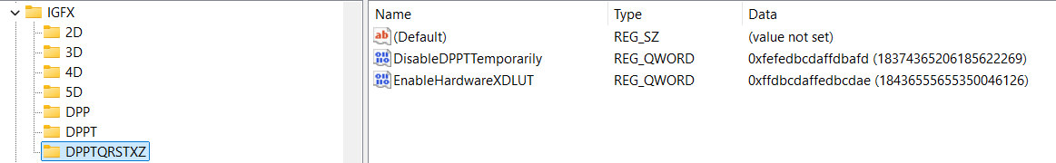

#### PSIS

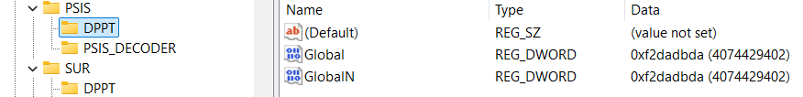

Or different solution which I am not preferring:

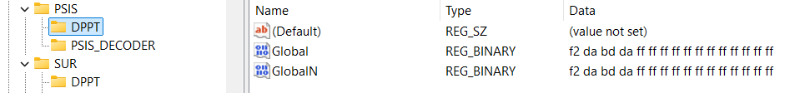

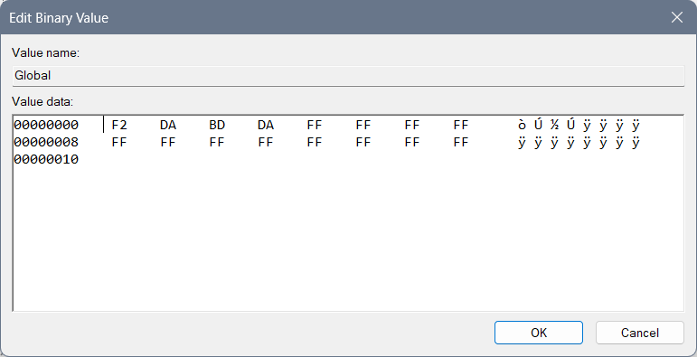

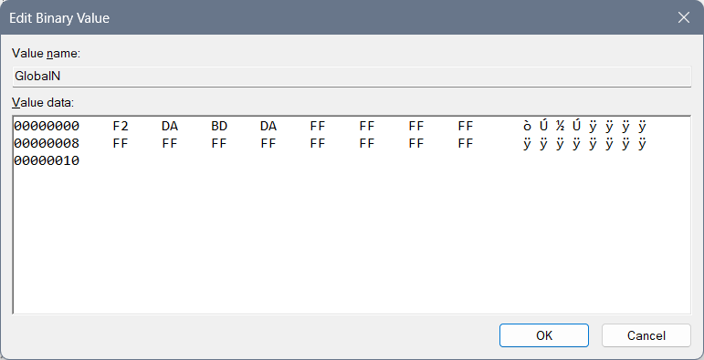

#### SUR

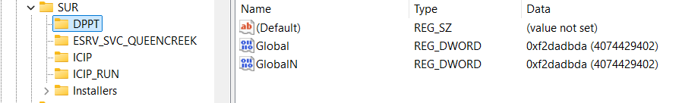

Or different solution which I am not preferring:

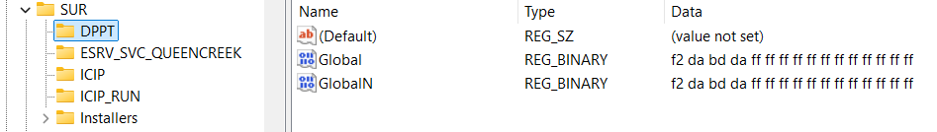

#### igfxcui

Files 3105 and 3106 leave the same, but create 3107, and 3108 and 3109…

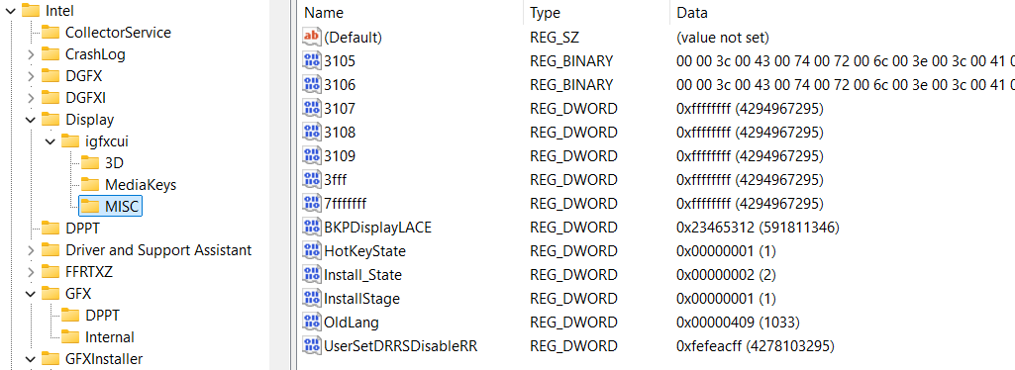

Here you can find a regular DRRSDisableRR which is 30… I set it to something that for me makes more sense…

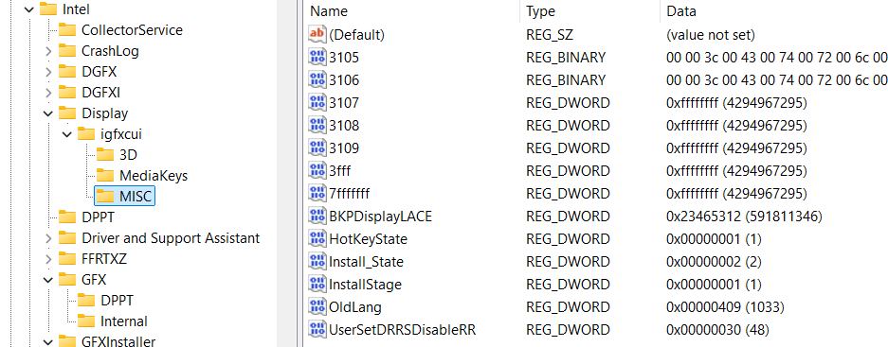

You can use this model with BKPDisplayLACE with all of the “f” chars but I do not suggest it because it represents open system of everyone around you and it doesn’t focus you on your job only…

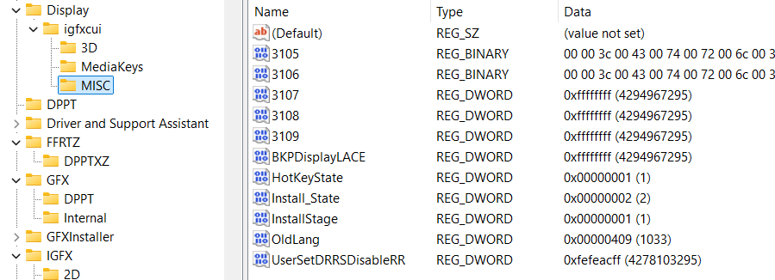

When you have a primitive idea of the 3D, you can implement 4D, 5D and up to 15D in the files as are dgfxcui (4D, 5D) and rgfxcui (6D, 7D, 8D), drgfxcui (9D, 10D, 11D), qxdrgfxcui (12D, 13D, 14D, 15D)… Each of those files should have the idea of the system speed being created by pixel movement to awake the brain idea of the cosmos jokes on the certain frequencies which is interesting because then user can see 3D image and so on…

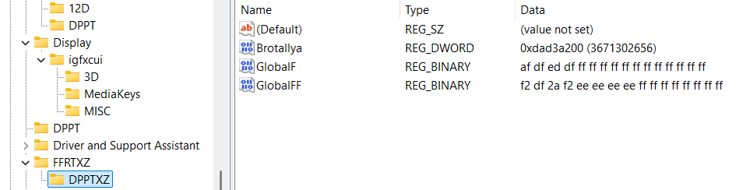

#### DRGFXZ

For Quanzyllyumar Display type regular values, and for a regular one type 8 times f: “ffffffff” into Ablagerio and Zeronimo…

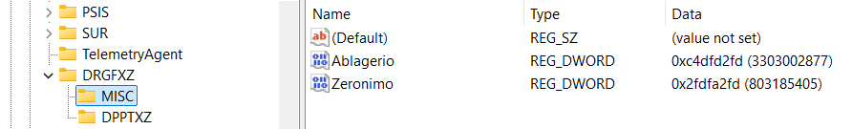

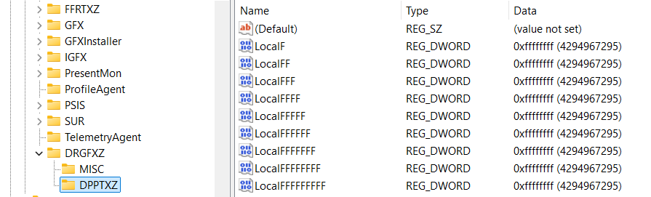

I believe if there is Ablagerio “ffffffff” and Zeronimo “ffffffff” then there is the key “DPPT” instead of “DPPTXZ”…

#### QDGFX

RSPTXD

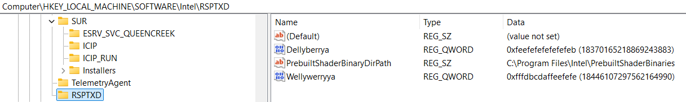

###### DPPTXZ

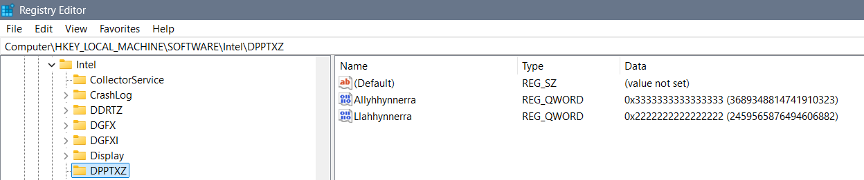

#### Banning

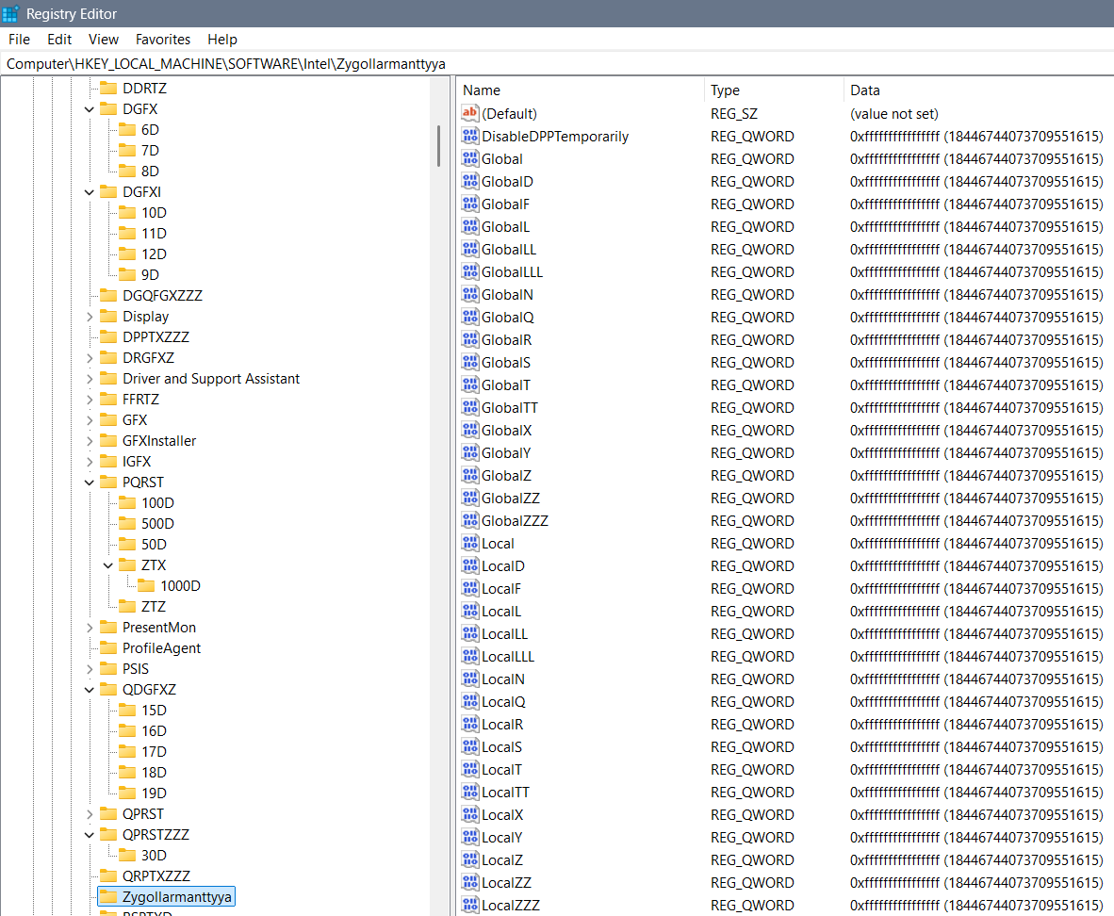

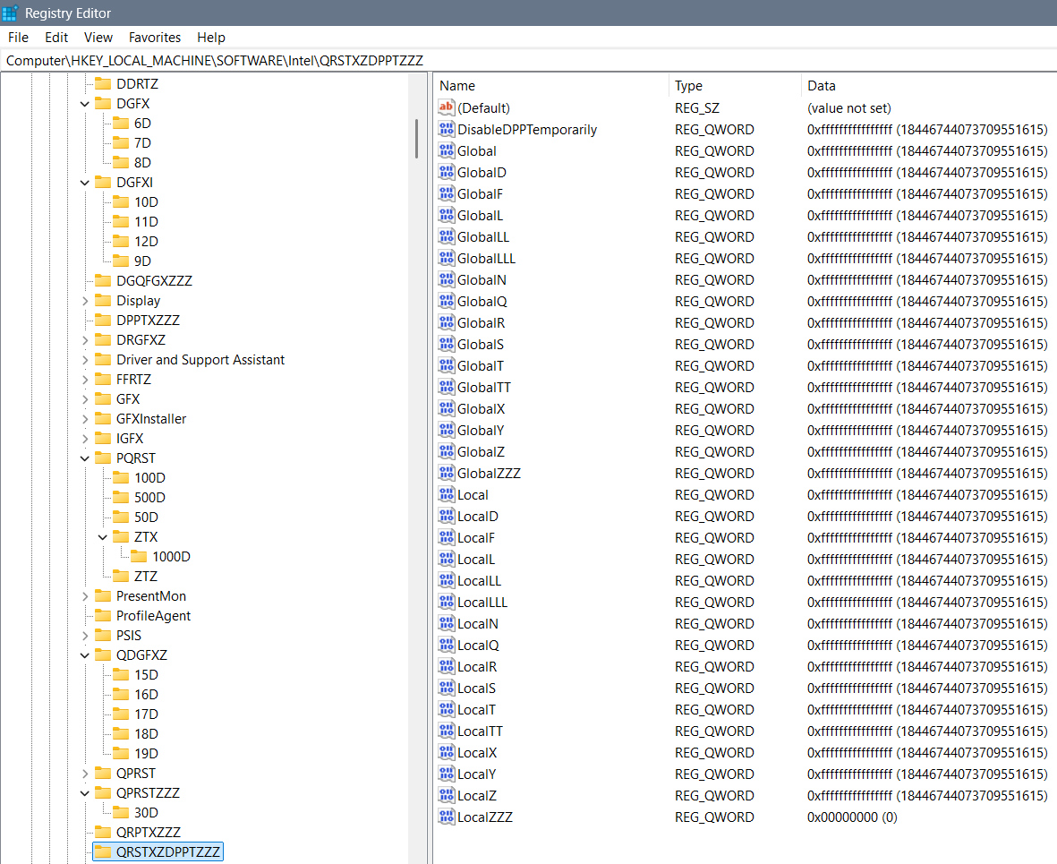

#### Something

Previously not good settings are moved to this part of the TXT without thinking and maybe these codes represent something, maybe they ain’t that good, but I find them unnecessary…

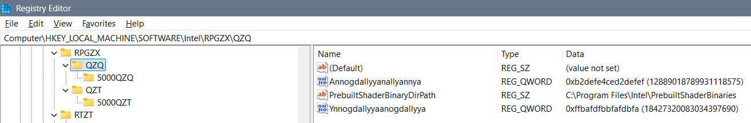

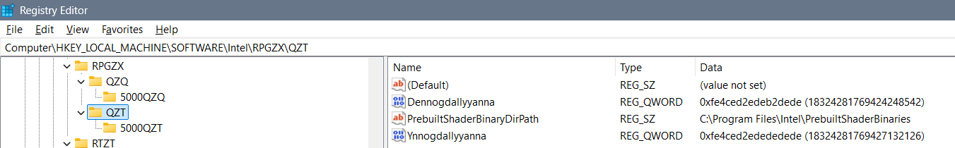

##### PRST

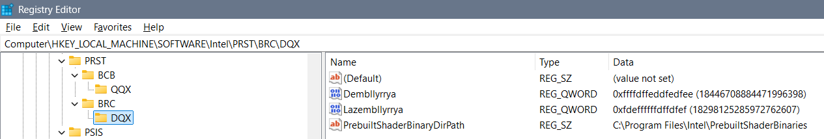

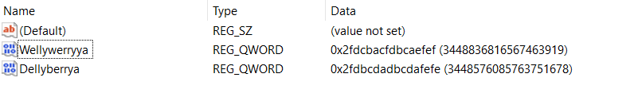

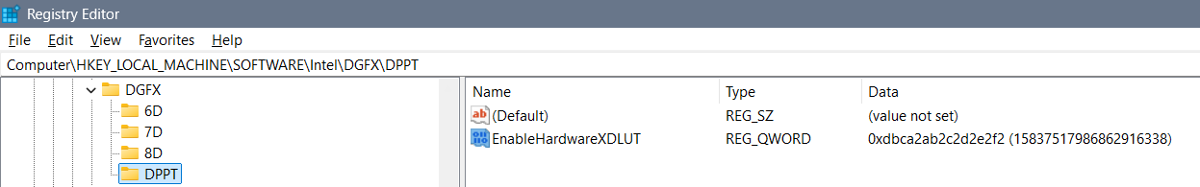

Fedbcdaefdfaefdf

Ayyannte

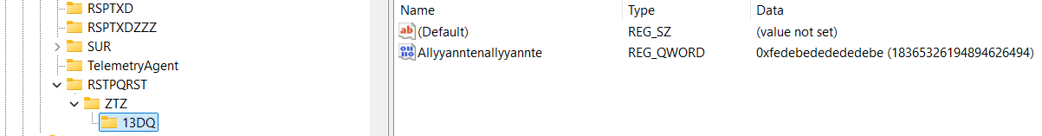

QDGFXZ

Zyndallya, Zembrallyya, Zemmallyya 3 bans on everything out there

Ffdbcdaffedbcdae

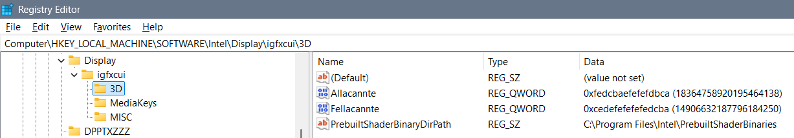

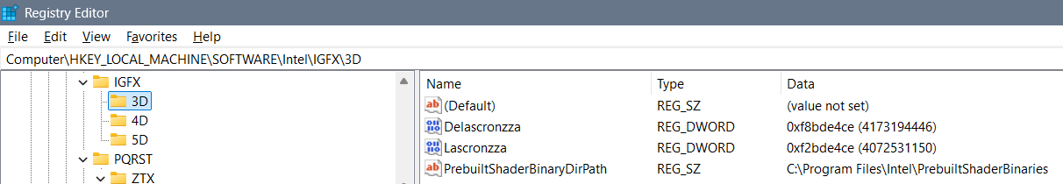

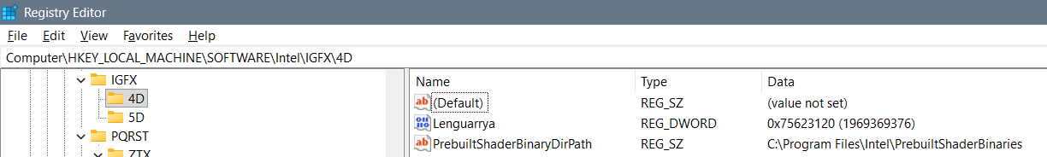

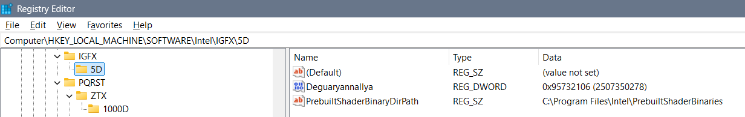

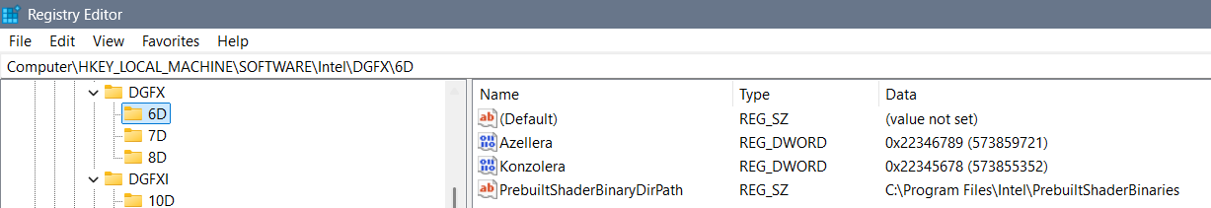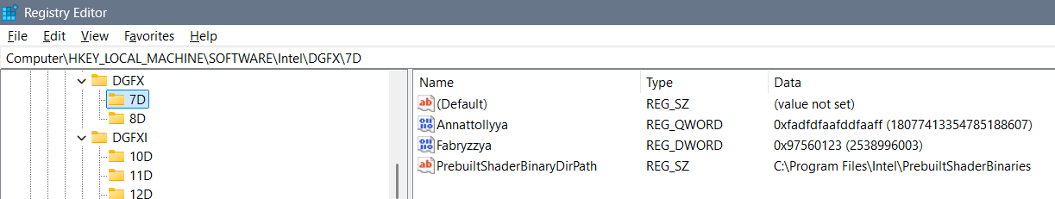

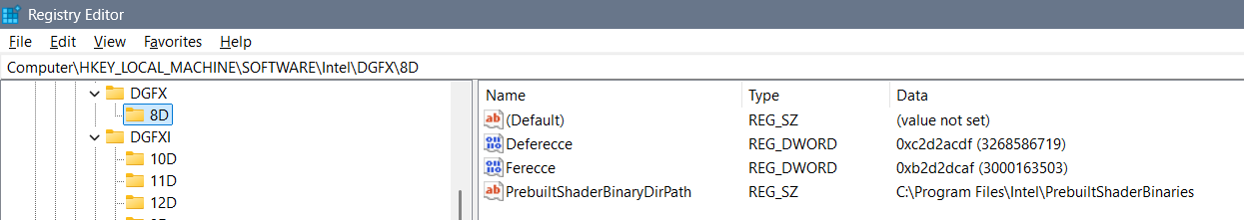

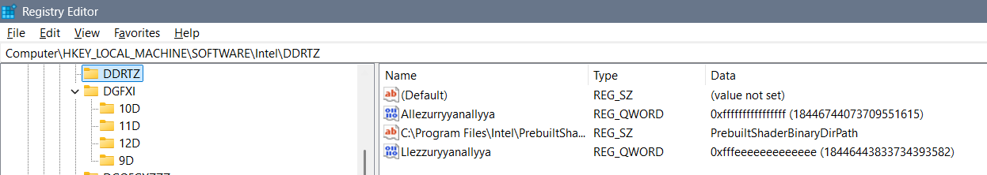

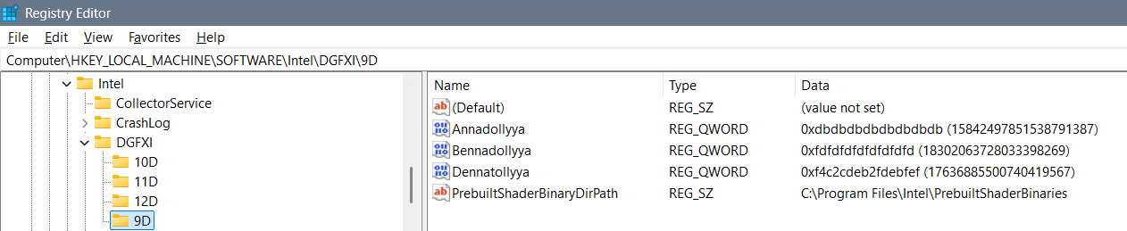

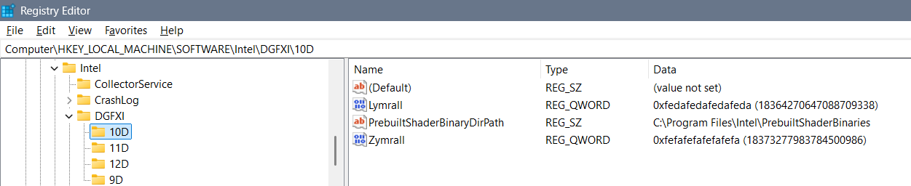

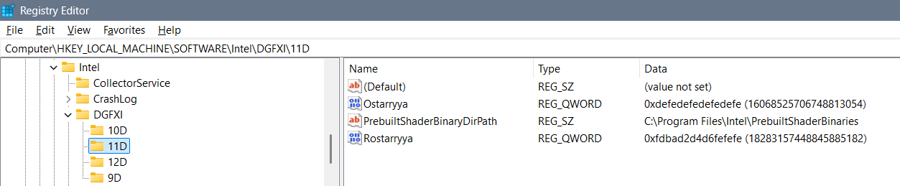

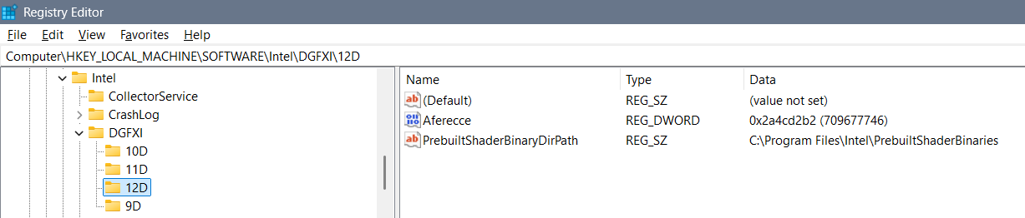

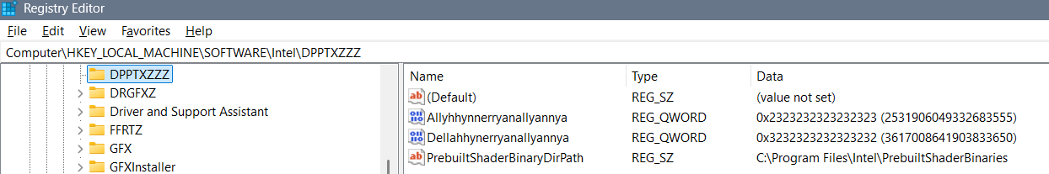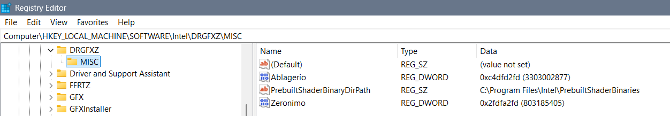

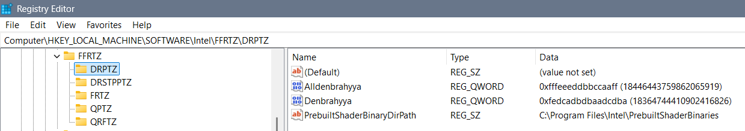

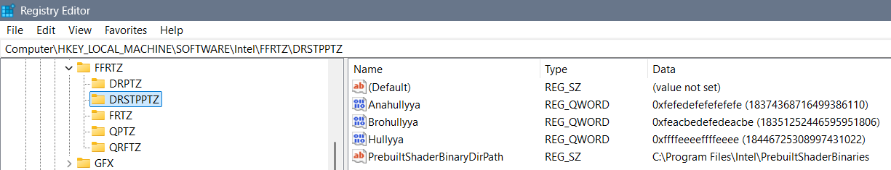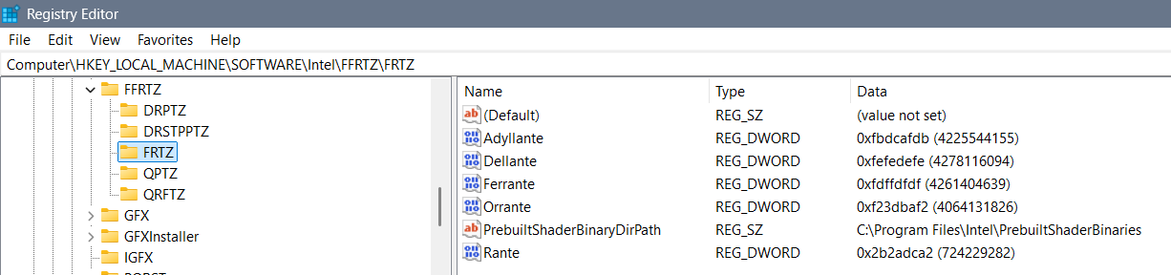

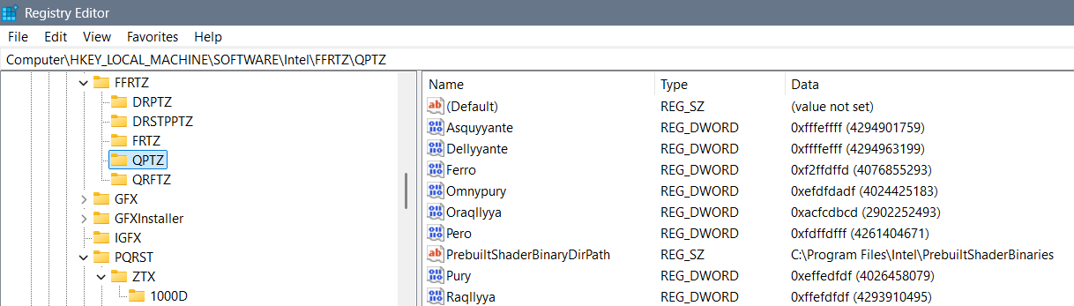

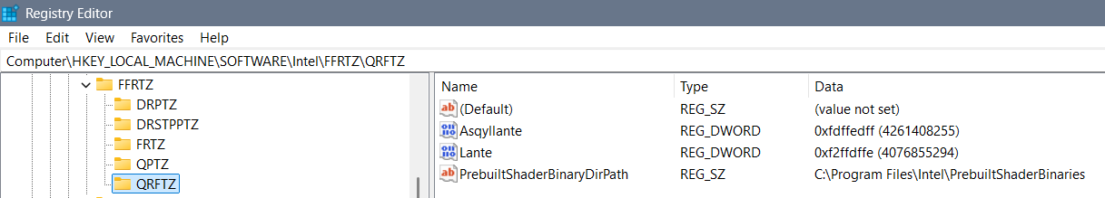

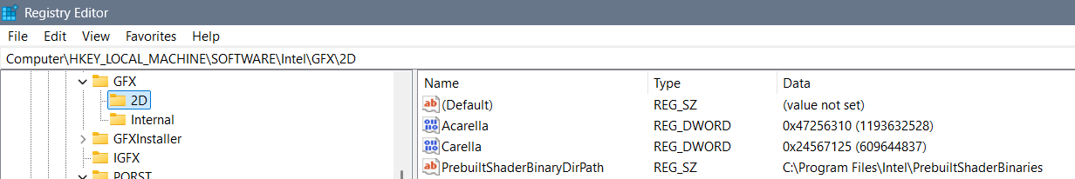

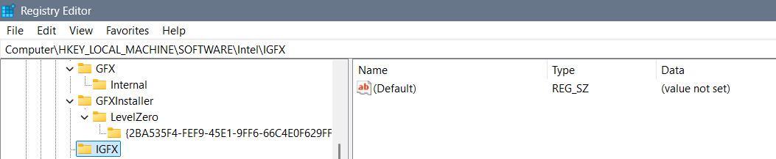

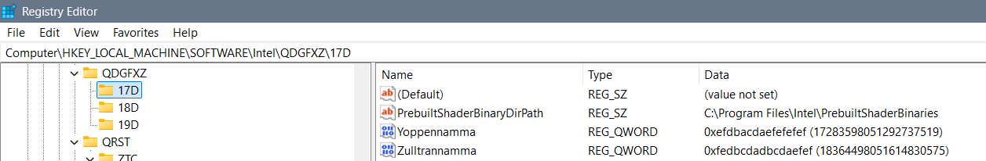

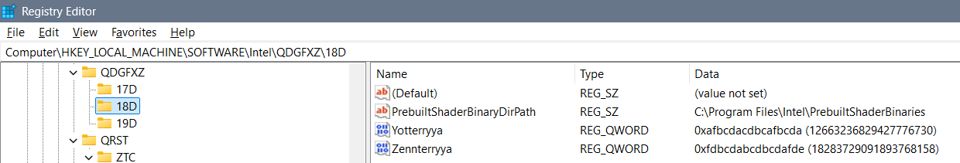

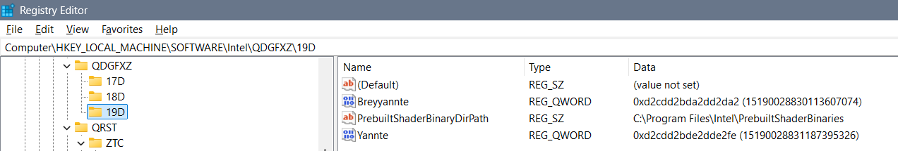

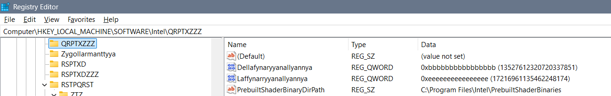

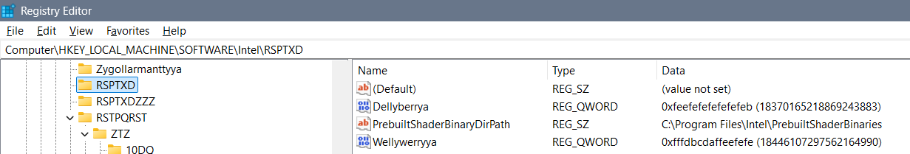

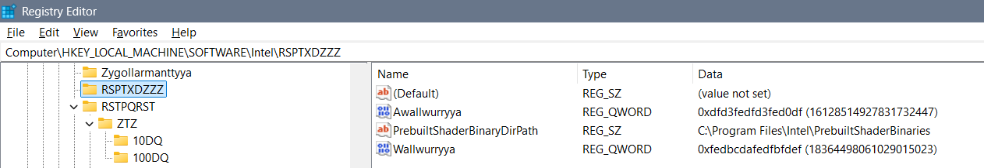

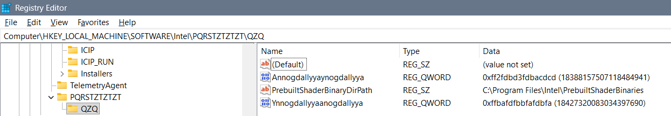

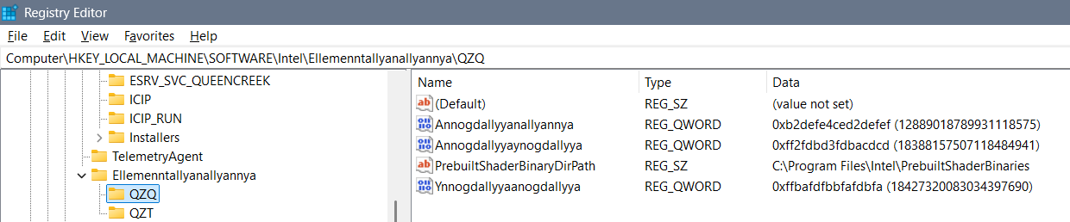

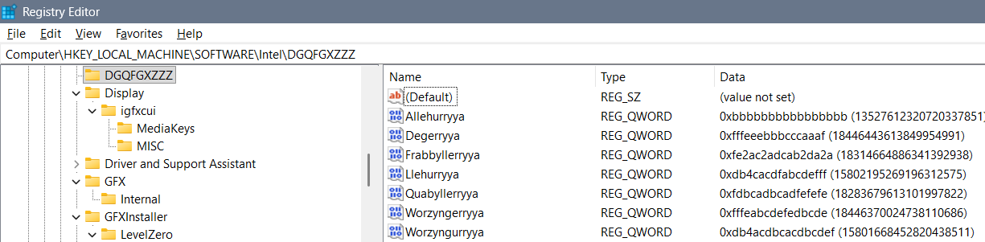

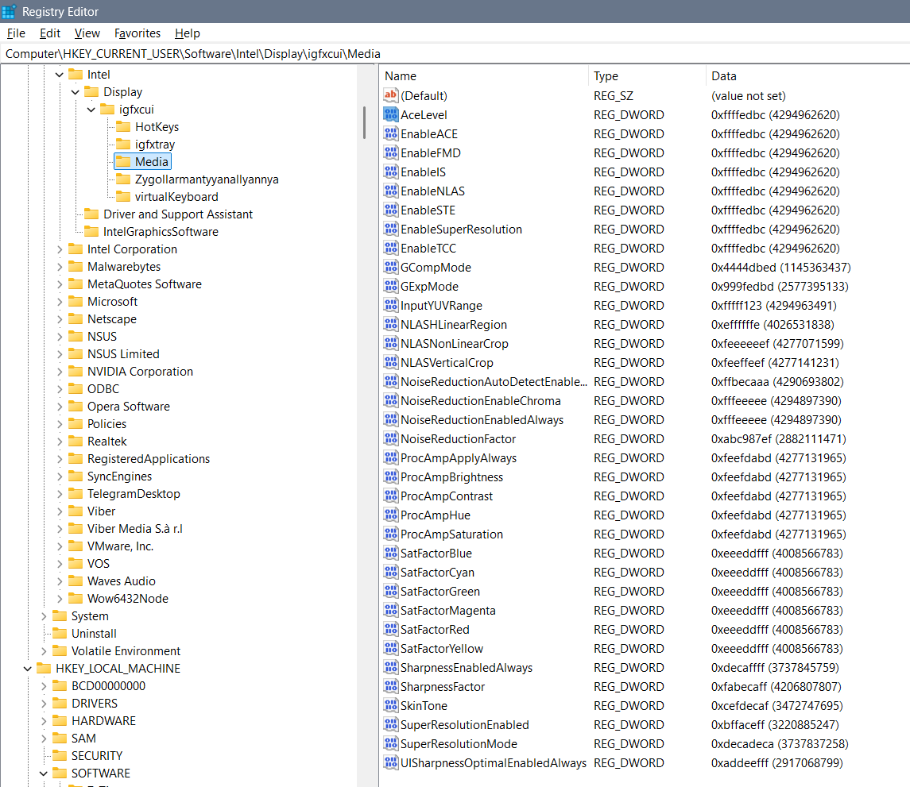

Ygullanttyyanallyannyya: bcdeefdbcdefeffe?

febcdeffbcdef4ce

Perryplexx Parrapllett

Parapplett

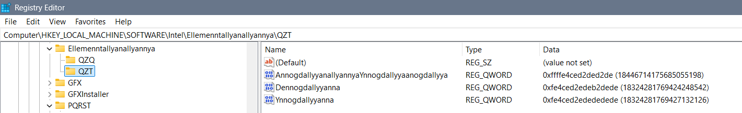

Ellemenntallyanallyannya – RPGZXDT

Zygollarmanttyyanallyannya - DPPTZZZ

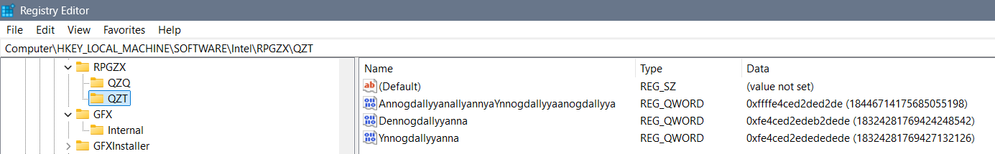

Allambrottyya PRSTQRST - DQX

Frygullarmantyya DQRST - DQ

Qupystallya DDRT – QZT – DQZ

Allambrrorryttyya - ZXQPRST – QZQ – DZXZQ

3DLUT - fe4cdefe4cefedef

DDQ Reallnyya Dereallnyya

Alldonbrerryya, Radonbrerryya

### Igfxcui/MISC

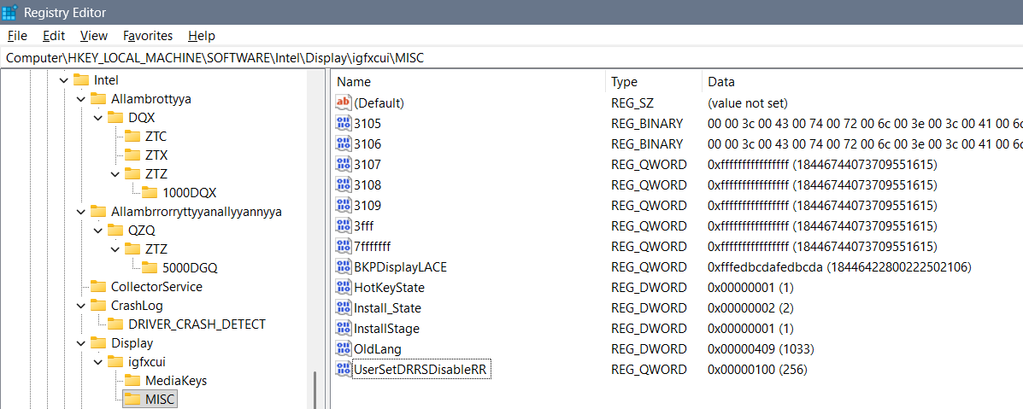

Possible options for DRRS-RR, in decimals, are best finishing with 9 as is 59, 109, and etc… All of the values I could think of are: 31, 59, 120, 256, 1024, 1759 of how much data you would like to be shown on the display and how for each user – so the best thing is to use all “f” – “ffffffffffffffff”… Maybe you can use “fdcdabdabddabdab” but I believe is wrong…

### igfxcui/Media - Old photos and not good settings

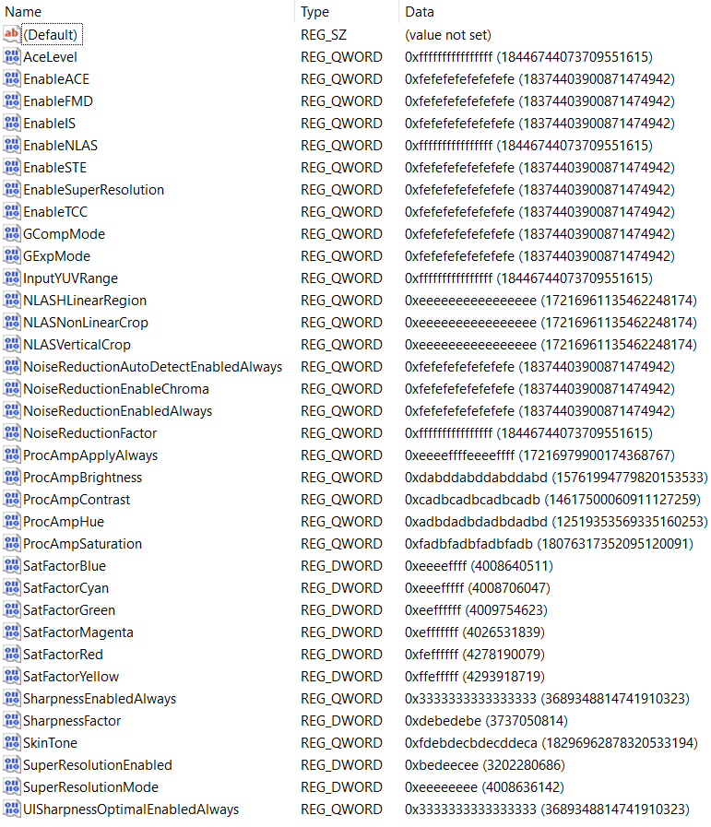

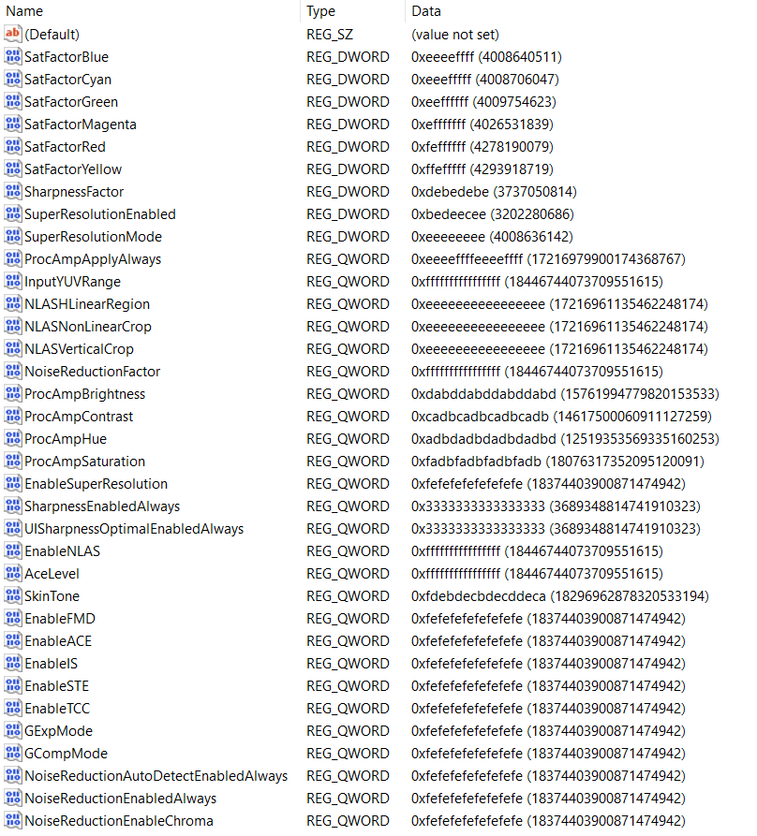

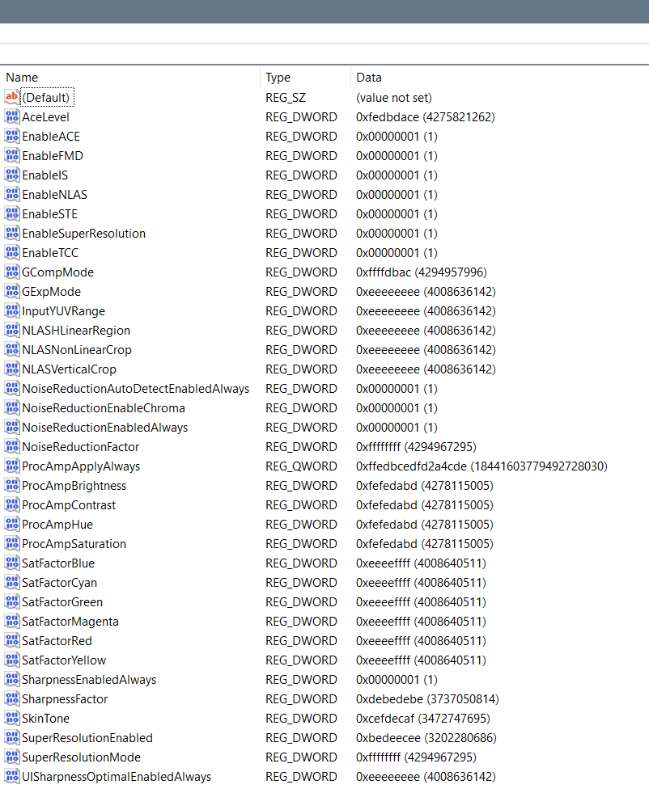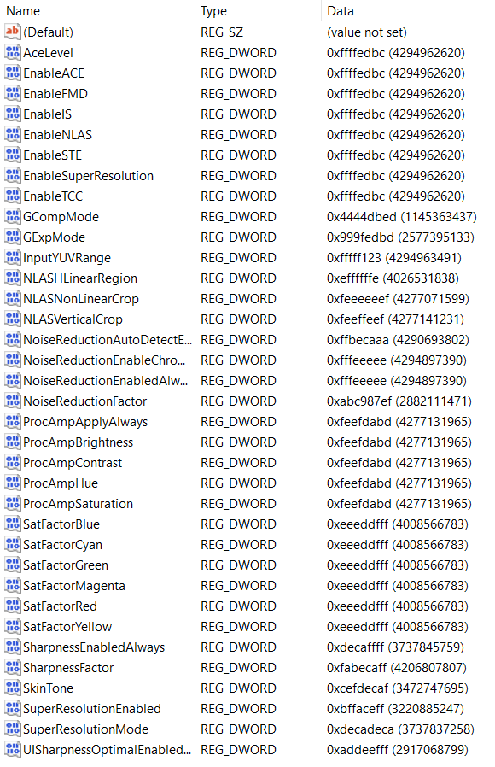

# Special thanks

Special thanks to the Cosmos joke of the creator which represents ExollynyStawrya (belonging to AllyStawrya beings) greatest thinker named “Razymodu”…

Support me at: [www.buymeacoffee.com/downness](http://www.buymeacoffee.com/downness)